Project Identification Form (PIF)
Project Type: Full-sized project
Type of Trust Fund:LDCF


PART I: Project Information
Project Title: | Promoting climate resilient community-based regeneration of indigenous forests in Zambia’s Central Province
Country(ies): | Zambia | GEF Project ID: | 5435
GEF Agency(ies): | UNDP | GEF Agency Project ID: | 4712
Other Executing Partner(s): | Ministry of Lands, Natural Resources and Environmental Protection (MLNREP); Department of Forestry (FD - under MLNREP); Ministry of Mines, Energy and Water Development (MEWD) – Renewable Energy Unit; Relevant District Councils; Ministry of Chiefs and Traditional Affairs (MOCTA) – District Council of Chiefs; Zambia Climate Change Network (ZCCN) | Submission Date:  Resubmission Date: | May 14, 2013  July 3, 2013
GEF Focal Area (s): | LDCF | Project Duration (Months) | 5 years
Name of parent program (if applicable):  - For SFM/REDD+  - For SGP | n/a | Agency Fee ($): | 369,075
A. indicative Focal AREA STRATEGY Framework:
Focal Area Objectives | Trust Fund | Indicative  Grant Amount  ($) | Indicative Co-financing  ($)
CCA-1: Reduce vulnerability to the adverse impacts of climate change, including variability, at local, national, regional and global level | LDCF | 1,185,000 | 7,109,633
CCA-3: Promote transfer and adoption of adaptation technology | LDCF | 2,700,000 | 16,589,143
Total Project Cost |  | 3,885,000 | 23,698,776
- indicative Project Framework

Project Objective: To increase the rate of forest regeneration and promote climate-resilient adaptation practices among forest-dependent communities in Zambia’s Central Province
Project Component | Grant Type | Expected Outcomes | Expected Outputs | Trust Fund | Indicative  Grant Amount ($) | Indicative Co-financing  ($)
1. Piloting of community-based, climate adaptive agro-forestry and assisted natural  regeneration techniques | TA (1.A – 1.E )  INV  ( 1.F) | Enhanced capacity of foresters and communities in Central Province to implement appropriate climate-resilient agro-forestry and natural regeneration practices in designated zones | - A. Participatory resource mapping and zoning (identification of suitable areas for agro-forestry and assisted natural regeneration measures ) taking alternative climate change scenarios into account completed in all six districts of Central Province  - Between 30-40 Village Action Groups (VAGs) formally recognized and constituted in zones by Y2 with clear resource rights and delineation of legally recognized VAG boundaries and use zones  - All VAG boundaries and use zones registered under the national Land Information Management System (LIMS)  - Training delivered for at least 20 district forestry officers and 2,000 VAG community members on site-specific appropriate climate-resilient agro-forestry and natural regeneration practices  - Wood fuel collection zones established in all VAGs and coppicing practices promoted  - Climate-resilient agro-forestry and ANR practices are piloted over 15,000 hectares under management in selected districts across the Province | LDCF | 800,000 (TA)  1,400,000  (INV)  2,200,000  (total) | 18,319,265
2. Integrated climate-resilient fire management | INV (2.A, 2.B)  TA (2.C- 2.E) | Robust fire monitoring and management protection plans and measures in place in all districts in Central Province to maintain desired regeneration targets and reduce fire frequency by 25%-30% annually across the province, within a four year burning cycle | - Geospatial fire occurrence dataset developed for Central Province based on satellite data and GIS mapping to ascertain burn severity classifications and climate change vulnerability of Miombo woodlands  - Fire management plans developed and operational (based on independent verification) for all targeted districts based on fire occurrence dataset and local inputs  - Firebreaks established around all ANR-treated sites done under Output 1.E  - District forestry staff , relevant VAG members and local authorities trained on appropriate climate-resilient fire protection practices (boundary and firebreak management, early burning, etc)  - Awareness raising campaigns undertaken across all districts about the benefits of adopting fire management measures to strengthen the adaptive capacity of Miombo forests to climate change | LDCF | 600,000 (INV)  600,000 (INV)  1,200,000  (total) | 3,947,133
3.Increased knowledge about and uptake of appropriate supply-side, biomass energy production technologies | TA (3.A, i and iii) &  INV  (3.A.ii & 3.B) | Energy efficient charcoal production and wood-saving technologies have successfully replaced inefficient systems in targeted areas of Central Province helping offset pressure on the forests as climate changes | - Deployment of technologies and development of sustainable charcoal schemes in 20 VAGs with (i) charcoal producer groups formed and trained to operate kilns; (ii) Charcoal retort kiln pilots introduced (120 improved kilns to replace earth kilns); (iii) Monitoring, tracking and licensing system established for all improved kilns piloted  - 50 charcoal or sawdust briquetting machines or presses piloted across 20 VAGs | LDCF | 150,000  (TA)  150,000  (INV)  300,000  (total) | 1,000,000
Subtotal |  |  |  |  | 3,700,000 | 23,266,398
Project Management Cost (PMC) |  |  |  |  | 185,000 | 432,378
Total Project Cost |  |  |  |  | 3,885,000 | 23,698,776

- Indicative Co-financing for the project by source and by name if available, ($)
Sources of Co-financing | Name of Co-financier | Type of Co-financing | Amount ($)
National Government | Ministry of Lands, Natural Resources and Environmental Protection (MLNREP) – Department of Forestry | Cash | 3,323,776
National Government | Ministry of Mines, Energy and Water Development (MEWD) – Renewable Energy Unit | Cash | 1,000,000
National Government | Ministry of Community Development, Mother and Child Health (Community Development Department) | Cash | 125,000
Local Government | District governments and local authorities in Central Province (District Councils, Community Resource Boards and District Council of Chiefs - DCCs) | In-kind | 100,000
GEF Implementing Agencies | UN REDD Program Zambia | Cash | 4,500,000
GEF Agency | UNDP Zambia | Cash | 100,000
Bilateral donor | USAID Zambia | Cash | 14,500,000
Non-governmental organizations | Conservation Farming Union (CFU)  of Zambia, DAPP and other NGOs. | In-kind | TBD at PPG phase
Non-governmental organization | Zambia Climate Change Network (ZCCN) | In-kind | 50,000
Total Co-financing |  |  | 23,698,776

- indicative trust fund Resources ($) Requested by Agency, Focal Area and Country1
GEF Agency | Type of Trust Fund | Focal Area | Country Name/Global | Grant Amount ($) (a) | Agency Fee ($) (b)² | Total ($) c=a+b
UNDP | LDCF | Climate Change | Zambia | 3,885,000 | 369,075 | 4,254,075
Total Grant Resources
¹ In case of a single focal area, single country, single GEF Agency project, and single trust fund project, no need to provide information for
this table. PMC amount from Table B should be included proportionately to the focal area amount in this table.
² Indicate fees related to this project.

- Project preparation grant (ppg)
Please check on the appropriate box for PPG as needed for the project according to the GEF Project Grant:
Amount Agency Fee
Requested ($) for PPG ($)
- No PPG required. ___-- 0--________ _ --0--_______
- (upto) $50k for projects up to & including $1 million ___ ________ ___ _____
- (upto)$100k for projects up to & including $3 million ___100K________ ___9,500K_____
- (upto)$150k for projects up to & including $6 million ___ ________ ___ _____

PPG Amount requested by agency(ies), focal area(s) and country(ies) for MFA and/or MTF Project only
Trust Fund | GEF Agency | Focal Area | Country Name/  Global | (in $)
 |  |  |  | PPG (a) | Agency  Fee (b) | Total  c = a + b
 |  |  |  |  |  | 0
 |  |  |  |  |  | 0
 |  |  |  |  |  | 0
Total PPG Amount |  |  |  | 0 | 0 | 0
MFA: Multi-focal area projects; MTF: Multi-Trust Fund projects.
part ii: project JustiFication
- Project Overview

Global environmental problems, root causes and barriers that need to be addressed

Zambia’s indigenous forests are under tremendous pressure, and the country’s deforestation rate is well above the global and regional average. Triggered by one of the highest urbanization rates in Africa, degradation is happening to such an extent that the country is now experiencing deforestation rates estimated in the range of 250,000 ha to 300,000 ha per year (ILUA 2008). Zambia’s forests have been identified as one of the country’s most valuable environmental and economic resource for supporting natural systems, regulating climate and improving sustainable livelihoods (GRZ, 2004, UN-REDD 2012). They are not only important for their specialized high-value timber species and fuel wood, they are also important repositories of biodiversity and provide a wide range of environmental services to wildlife and wildlife-based tourism, agriculture, biomass energy, hydro-electricity generation and water supply by regulating watercourses and flood regimes. Zambia’s forests also play a significant role in terms of contribution to GDP and poverty reduction, as well as potential for climate change adaptation and carbon management.

A majority of Zambia’s poor rely on natural resources for their livelihoods. For households living adjacent to forest areas, a large share of the household income is derived from forest products (see Figure 1). The official contribution of the forestry sector to GDP has been estimated at 6.3% at constant 1994 prices (Mwitwa, 2009). Forest resources contributing to GDP and livelihoods are primary non-timber forest products (NFTPs) such as medicinal products (leaves, tubers, fiber, fruits, roots, twigs); wild mushrooms; bulbs and tubers; wild vegetables; and fruits. Wood products and pulp and paper are primarily industrial products.

Firewood is largely consumed in rural areas where electricity as a source of energy constitutes only two percent of primary energy supply. Charcoal is also produced in rural areas and is the major source of energy in Zambia’s peri-urban and urban households. Over 7 million m³ of wood is annually removed from Zambian forests for the purpose of wood fuel use and the charcoal sub-sector is a major source of employment. Meanwhile production estimates for value-addition by the forestry sub-sector are now estimated at approximately USD12 million per annum (Ng’andwe et al., 2009). Based on the latest available data, wood harvesting for industrial use has now reached over 1 million m³ per annum, estimated at 59,000 m³ from indigenous forests; 311,000 m³ from plantations; and 777,000 m³ from other modified forests. As regards employment, an estimated 1,100 persons are employed by the Forestry Department; 9,000 are employed in the wood manufacturing sector; 152,000 in biomass energy; and 888,806 in the NTFP sub-sector, leading to a total employment figure in the national forestry sector of an estimated 1,050,906 persons The informal NTFP sub-sector is therefore among the largest employers in the country.

Figure 1 – Income shares of forest-adjacent rural households (Source: CIFOR 2010)

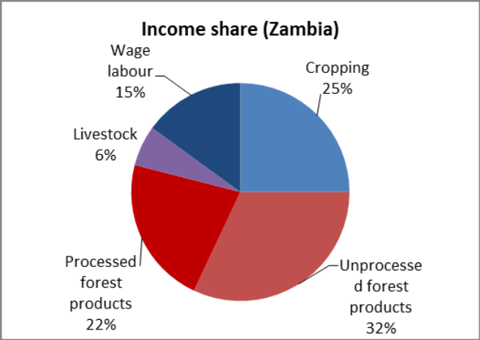

Zambia’s forests are at the heart of the Miombo Eco-region, which is listed as a WWF Global 200 Eco-region because of its high species richness. Also referred to as the Zambezian Regional Centre of Endemism, this area covers some 3,770 million km² extending from the Katanga (DRC) to the Vaal River (South Africa). Besides its role in supporting livelihoods and managing climate change, the eco-region supports important populations of fauna and is also floristically diverse, harbouring some 8,500 plant species, of which approximately 54% are endemic (WWF-SARPO, 2002). At present Miombo woodland is the most extensive Zambian ecoregion covering about 65% of the country (see Figure 2). Miombo is further divided into Central Zambezian and Southern Miombo Woodlands. The central Miombo woodland which is predominantly of Isoberlinia angolensis, Brachystegia spp. and Julbernadia paniculata is the dominant vegetation types in Northern, Luapula, North-Western and the northern part of Central Province and part of Kafue National Park. In the southern Miombo woodland, Isoberlinia angolensis is absent.

Figure 2 – The Major Eco-Regions of Zambia

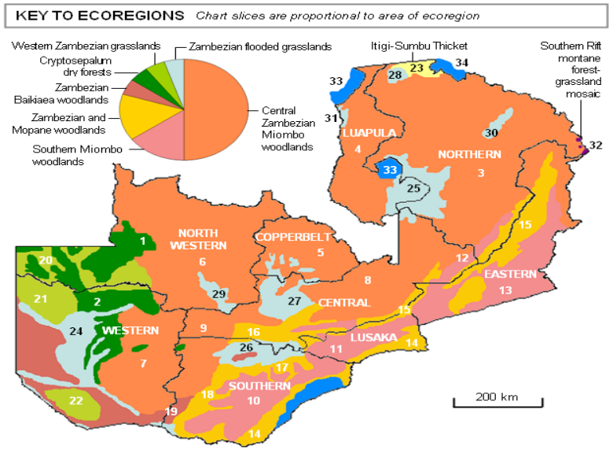
Project focus

The management of Zambia’s woodlands – or lack of it – affects not only local communities, who are almost totally dependent on them for their livelihoods, but also the whole nation and even the broader region since the water flow in large rivers like Zambezi are affected by deforestation and degradation. Natural forests such as Miombo and Mopane forests are exploited in an uncontrolled manner in many parts of the country, and are now close to depletion in many areas. A typical practice involves clearing forests for cultivation and then abandoning the area some years later as unproductive, thus leaving the land exposed to rain and sun; the valuable remaining minerals are then washed away and the top soil is dried up and it becomes very difficult to regenerate a new forest in the area. Uncontrolled timber logging and cutting trees for charcoal burning has a similar effect on the land.

The Experience of Zambia’s Central Province in Efforts to Protect Miombo Woodlands
Several forest management models have been tried in Zambia to promote joint stewardship of forests. Joint Forest Management (JFM) of forests and minor forest products was originally done in protected forest areas (local forests only) and open areas between local communities and the Forestry Department (FD). In the early 2000s, FD piloted JFM in more than 20 areas across the country, supported by a range of donors (Finland, FAO, IFAD, UNDP and USAID). At the same time the Integrated Land Use Assessment (ILUA) I project generated national-wide data on the current forest resources and other land-use regimes. ILUA II is currently on-going to mainly generate forest resources data that could be used for land use planning at district level and to develop a system for monitoring deforestation rates. In the last decade, the forest department introduced JFM as part of the Provincial Forestry Action Plan (PFAP) to initiate the local community to co-manage the forests in traditional lands. Unfortunately since 2006, the JFM pilots are all defunct.

Central Province – situated in the heart of the country and sharing boundaries with all the other eight provinces and DRC in the West – has been one of the Zambian provinces with the most experience in piloting such models and other related initiatives, many of which were implemented by the FD. Administratively, Central Province is divided into six (6) districts: Chibombo, Kabwe, Kapiri Mposhi, Mkushi, Mumbwa and Serenje (see Figure 3 below). The smallest district is Kabwe District, located in the middle of the Province, which also houses the Provincial headquarters.

Figure 3 – Map of administrative boundaries in Central Province

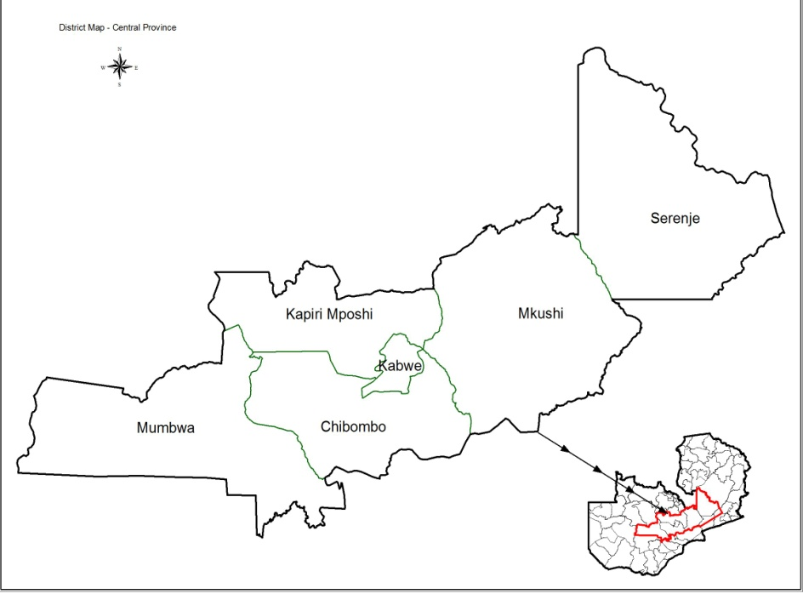

In terms of population, based on the 2010 census Central Province is estimated to have a total of 1,267,803 (about 1.3 million) people, of which 640,980 are women and 626,823 are men (see Table 1). According to the census between 2000 and 2010 the population in the province grew by 255,546 people, representing a 20.15% increase. Unsustainable land use practices continue to make people move from one piece of land to another after the former is degraded.

Table 1 - Population Change & Distribution in Central Province (2000 and 2010)

LOCATION | 2000 |  |  |  |  | 2010
LOCATION | TOTAL | FEMALE | % | MALE | % | TOTAL | FEMALE | % | MALE | %
National | 9,885,591 | 4,939,293 | 49.96 | 4,946,298 | 50.03 | 13,046,508 | 6,652,053 | 50.99 | 6,394,455 | 49.01
CENTRAL PROVINCE¹ | 1,012,257 | 501,756 | 49.57 | 510,501 | 50.43 | 1,267,803 | 640,980 | 50.56 | 626,823 | 49.44
DISTRICT
Chibombo | 241,612 | 119,664 | 49.52 | 121,948 | 50.48 | 293,765 | 148,327 | 50.49 | 145,438 | 49.51
Kabwe | 176,558 | 87,755 | 49.65 | 89,003 | 50.35 | 202,914 | 103,353 | 50.93 | 99,561 | 49.07
Kapiri Mposhi | 194,752 | 96,194 | 49.39 | 98,558 | 50.61 | 240,841 | 121,998 | 50.74 | 118,443 | 49.26
Mkushi | 107,438 | 52,810 | 49.15 | 54,628 | 50.85 | 151,803 | 75,739 | 49.89 | 76,064 | 50.11
Mumbwa | 158,861 | 78,066 | 49.45 | 79,795 | 50.55 | 218,328 | 110,177 | 50.46 | 108,151 | 49.54
Serenje | 132,836 | 66,267 | 49.89 | 66,569 | 50.11 | 160,152 | 81,386 | 50.82 | 78,766 | 49.18
¹ In 1990, population in Central Province was as follows: Provincial Total =771,818; Female =386,588; and Male= 385,230.
² National Total = 7,759,117; Female = 3,917,541; Male =3,841,576.

Source: Zambia 2010 Census of Population & Housing: Preliminary Population Figures.

Central Province is the bread basket of Zambia and also accounts for the largest number of commercial farming blocks in the country; as a result it is one of provinces with the largest amount of deforestation from farmland expansion. Major crops grown in the province include – but are not limited to – maize, tobacco, cotton and Irish potatoes. It is also a major charcoal producer (mainly for transport to Lusaka and Copperbelt Provinces) and in a survey of the four major agriculture-based provinces it ranked highest in charcoal use as the primary cooking fuel (see Table 2 below).

Table 2 – Main Household Cooking Fuel Use by Selected Provinces

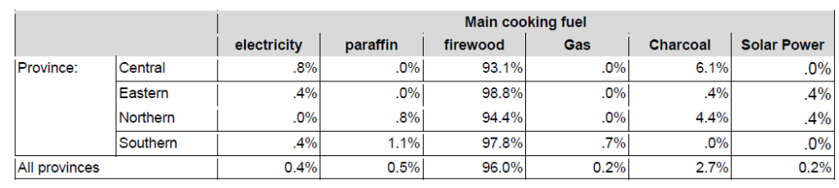

Source: Baseline Report for AGRA’s Interventions in Zambia, Rubicon Management Consultants, 2010

A UN-REDD Stakeholder Analysis and Engagement Plan for Central Province was drafted in 2011 and surveyed many of province’s experiences with initiatives designed to reduce forest degradation and deforestation. The following is a summary of the province’s experiences to date in this regard:

- The PFAP was originally piloted in Kabwe and Mkushi districts and although the JFM approach received wide support, the results were not as successful as expected due to legal, administrative and programmatic challenges which were not envisioned at the beginning of the JFM schemes. A draft management plan was developed under the PFAP for the Myafi Local Forest in Mkushi district as well as the Chibwe National Forest in Kapiri Mposhi; however the implementation of the management plans and other JFM plans stalled in the mid-2000s as already noted. A case study of the JFM experience of Chibwe National Forest in Kapiri Mposhi district is detailed in Annex 5.

- The parastatal Zambia Forestry and Forest Industries Corporation (ZAFFICO) was developed from the Industrial Plantations Division of the Zambia Forest Department with the help of a World Bank loan in the early 1980s. Many of its plantations were based in Central Province. ZAFFICO was established to help meet the increasing demand for timber in Zambia and to complement supplies from indigenous forests which were being overexploited.

- A variety of agro-forestry interventions have been promoted by ICRAF in the province, particularly in Chisamba and Chibombo and some parts of Kabwe and Mkushi. Following major forest loss due to tobacco farming, some farmers have taken up tree planting to cushion their farm enterprises. Currently, Mkushi farming block and some farmers in Chisamba provide good examples of private forest plantations.

- Some local NGOs such as Conservation Farming Unit (CFU) and DAPP are promoting conservation farming in the province. These interventions are slowly making a positive impact in Mumbwa, Chibombo, Kabwe, Mkushi and Serenje.

These and other past initiatives have laid the foundation for a strong base of learning and application of SFM practices in the province. As noted in a recent AGRA survey assessing household knowledge of SFM and SLM practices across four provinces with agricultural-dominated economies, Central Province was the province where the highest percentage of respondents (61.2%) indicating that they had practiced SFM/SLM practices or technologies in the past two years (2008-2010) – see Table 3 below.

Table 3 – Level of SFM/SLM Knowledge by Selected Provinces

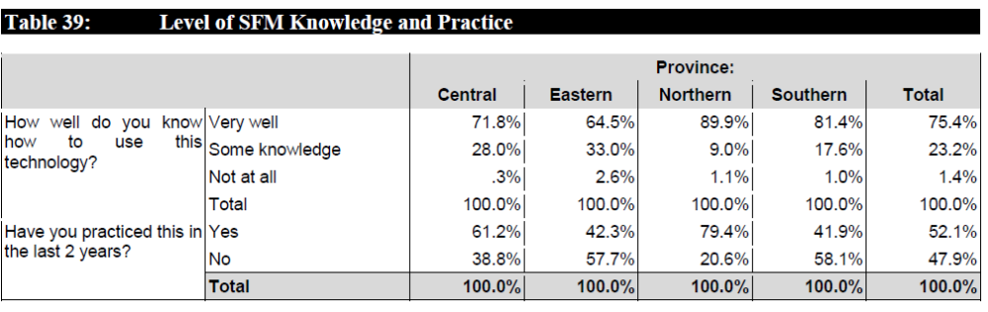

Source: Baseline Report for AGRA’s Interventions in Zambia, Rubicon Management Consultants (2010)

While this survey findings present promising trends, Zambia’s woodlands are facing the added challenge that the projected increase in temperature in the country due to climate change – compounded by rampant deforestation – is slowing down the regeneration capacity of the country’s Miombo forest, which has traditionally been a resilient and balanced ecosystem. The country’s First National Communication under UNFCCC (MTENR 2000) concluded from its analysis that there is a high chance that Miombo woodlands will be negatively impacted by climate change impacts: “Projections of future vegetation distribution patterns indicated that under projected climatic variables 1, Miombo woodland cover would suffer a 50 percent reduction across the country whereas Mopane and Munga would predominate. The Kalahari and Dry Evergreen forest (e.g . Cryptosepalum, Parinari and Marquesia) would disappear. For another set of projected climatic variables, the country would be predominantly covered by Miombo, Chipya, Kalahari and Cryptosepalum while Mopane, Munga and Baikiaea species would disappear.”

Meanwhile the vulnerability of Zambia’s Miombo woodlands to climate change is further underscored by a recent report on the Economic Impacts of Climate Change in Zambia that estimates that the real cost of climate change in degradation of natural resources over the next 10 years may be as high as $5.5 billion. That report specifically estimates the cost of climate change based on two scenarios: 1) if the stock of Zambia’s natural resources are assumed to be US $35 billion (actual cost; not lost GDP); and 2) based on the actual foregone GDP as a result of climate change impacts on Zambia’s natural resource stocks. Impact D in the study is “Increased frequency of fires and accelerated forest retreat” and has an estimated cost per annum of US$0.39 billion (actual cost) and estimate cost per annum from lost GDP of US $14 million per annum.

Root causes of the loss of forest area and lack of natural regeneration in Miombo woodlands

Currently, the most common practices leading to the loss of forest area and lack of natural regeneration in Miombo woodlands (including those in Central Province) are:

- The opening of new land for agriculture;
- Inefficient production of charcoal and harvesting of wood fuel for domestic, commercial and industrial purposes and inefficient biomass cooking applications;
- Late burning and uncontrolled fires in the dry season;
- Uncontrolled logging of timber and over-harvesting of key species;
- Unsustainable agricultural methods; and
- Other land use practices, e.g. expansion of settlements.

Several of these practices are intricately linked to climate change-related risks and uncertainties. For example in the face of climate change it is clear that the natural regeneration of Miombo woodlands is facing major challenges as regards soil degradation, competition with weedy species, and recurring disturbances which inhibit natural regenerative processes. Climate-adaptive, agro-forestry and assisted natural regeneration techniques have proven effective on a limited scale but have not yet been mainstreamed into traditional agricultural methods and communities across the country and many communities are unaware of the need to manage Miombo woodlands in a sustainable manner.

Traditional charcoal production activities are also a major impediment to sustainable management of Miombo woodlands. In all cases, customary land and national forests are the major sources of charcoal. For those rural inhabitants who are able to access public roads which lead to major urban centers, sale of charcoal is one of the few available livelihood options which can generate cash income in the remote and undeveloped rural districts and it is widely practiced. Traditional charcoal production is a particularly damaging and degrading activity due to the destructive method of harvesting the entire tree, as well as the carbonization process which involves the controlled burning of piled logs in an improvised kiln of mounded earth (referred to as a an “earth kiln’). The traditional earth kilns are very inefficient, seldom achieving a wood-to-charcoal conversion efficiency of more than 20%, and cause extensive local degradation and soil erosion due to the intense heat generated by kilns as well as deforestation due to the clear-cutting of trees and construction of kilns. It is estimated that ~5% of an area cleared for charcoal production by earth kilns will not regenerate. Furthermore, most charcoal production occurs on public land where there is little incentive to conserve forest, replant trees or practice low-impact harvesting techniques such as coppicing of trees to allow for regeneration. Instead most trees are felled at ground level, thereby limiting the capacity for woodland to regenerate after harvesting.
A recent USAID-funded study of charcoal consumption and production in Eastern and Lusaka Provinces estimated that 0.01 ha of undisturbed forest is cleared annually for every ton of charcoal consumed. That study (see Figure 3) estimated that in 2030 the national deforestation rate from charcoal production (under a BAU scenario) would be 51,866 ha per year. The annual charcoal consumption for the Copperbelt, Eastern and Lusaka Provinces was estimated at a total of 1,423,400 tons leading to the loss of 14,234 ha of forests annually. That same study estimated that the bulk of the charcoal transported into Lusaka Province is from Central Province.

Figure 4 – Estimation of Deforestation from Charcoal Production (2011-2030)

for Eastern and Lusaka Provinces (Source: USAID)

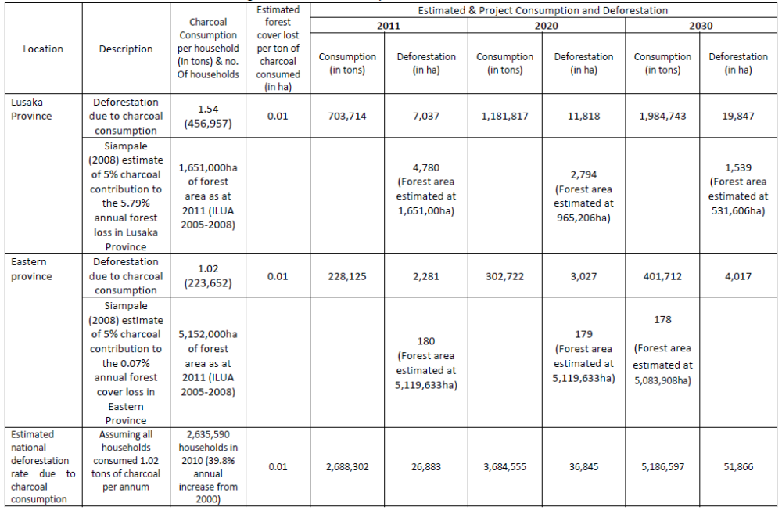

A further key climate-induced threat to Miombo’s natural regeneration capacity is fire. In the past Miombo was traditionally considered a ‘fire climax’ ecosystem which is adapted to periodic cycles of fire, as a result of the accumulation of low-growing grass, shrub and plant litter below the relatively open woodland canopy. However as a result of climate change impacts combined with and the uncoordinated and ad-hoc nature of fire management in the country and a lack of awareness and education on fire management systems, Zambia’s forested areas have been subjected to fires of increasing intensity and frequency. The increased frequency and intensity of fires in Miombo woodlands (caused by both climate change and human factors) will reduce the function and corresponding carbon sequestration capacity of ecosystems. Soil fertility is depleted by the loss of nutrients as a result of repeated burning of biomass. The prolonged removal of protective vegetation cover and increased oxidation of soil organic matter negatively impacts on soil structure, moisture-holding capacity and vulnerability to erosion. Fire can also change the composition of woodland, promoting fire-resistant species (e.g. with thick corky bark) at the expense of fire tolerant species.

Long-term research which investigated the effect of increased intensity and regularity of fires on Miombo vegetation found that continued annual or biennial occurrence of fires resulted in increased mortality of young and mature trees, reduced recruitment and establishment of tree seedlings, and a shift towards short-lived fire tolerant grass and shrub species. Model predictions suggest that sustained annual fires will result in a conversion of Miombo woodland to a treeless landscape with a net reduction in ecosystem biomass and carbon, as well as increased vulnerability to climate change impacts.

Conversely, early-season fires (which are less intense and less extensive than late-season fires as a result of the higher moisture content of vegetation and smaller quantities of accumulated litter and dead wood), tend to burn at a lower temperature, and can have a neutral or net positive effect on woody biomass accumulation by Miombo trees. In the long term, increased incidence of late dry season fires in Miombo woodland drive shifts in vegetative composition and aboveground biomass density. It is clear that if late season fire frequency increases beyond a critical fire return interval, the regeneration capacity of Miombo may be irreversibly impacted.

As an example of the severity of the problem and associated economic impacts, recent studies done as part of the preparation of another GEF-funded project suggested that the annual loss of carbon from late season fires varies from 1.32 t/ha in Miombo to 1.52 t/ha in Cryptosepalum forest. In Kafue National Park – the heart of the greater Miombo Ecosystem – an average of 1,251,600 hectares burns annually. If standard assumptions are applied, late season fires ‘cost’ Kafue NP some 839,209 tons CO2 per annum. Integrated fire management is therefore essential for forest conservation, assisted natural regeneration and as a part of any sustainable climate change adaptation strategy.

From all of the trends mentioned it is clear that no intervention in Zambia’s Miombo woodlands means business as usual, with practices based on the premise that the forest will adapt more or less as it has in the past. All of the scenarios presented confirm that in the face of climate change this is no longer the case. Planned adaptation involves redefining forestry goals and land use practices in advance of climate change-related risks and uncertainties and this is urgently needed in the case of Zambia’s Miombo ecosystem.

Problem Statement: Zambia’s forests play a significant role in terms of contribution to GDP and poverty reduction, as well as potential for climate change adaptation and carbon management. However the increased frequency of fires and accelerated forest retreat in Zambia’s Miombo woodlands caused by climate change and exacerbated by deforestation has been estimated to cost Zambia annual lost GDP of US $14 million per annum. While in the past Miombo woodlands have been a resilient and balanced ecosystem, unsustainable anthropogenic land use and energy practices – combined with climate-induced impacts – are severely inhibiting the natural regeneration capacity of this ecosystem. These pressures are especially pronounced in the country’s Central Province, which has largest number of commercial farming blocks in the country and is one of the major production areas for charcoal.

The baseline scenario and any associated baseline projects

In an effort to address the problem statement above and its root causes, this project aims to increase the rate of forest regeneration and promote climate-resilient land management and energy practices among forest-dependent communities in one area – Zambia’s Central Province – building on a variety of new national platforms and other province-level initiatives that are being piloted in other parts of the country.
Management of Zambia’s forests – both national forests and those on traditional lands – remains a continuing challenge. As noted in a new study funded by UN-REDD “Sustainable Forest Management Initiatives of relevance to REDD + in Zambia” National Forests are relatively protected – at least in theory. The law states that “all land in a National Forest shall be used exclusively for the conservation and development of forests with a view to scouring supplies of timber and other forest produce, providing protection against floods, erosion and desiccation and maintaining the flow of rivers” (Forest Act 1973, Part III, para 12). No activities are allowed in the forest without explicit permission – including entering the forest.

However as noted in the report: “in practice, the Forest Department is not capable of providing day-to-day protection and management of the National Forest Estate. The standard forest management practice involves the application of prescriptions such as (i) inventory; (ii) protection, e.g. early burning, boundary demarcation, and the management of pests and diseases; (iii) enforcement of legislation, e.g. patrols to prevent illegal activities and supervision and monitoring of license-holders; and (iv) silvi-cultural operations, e.g. felling systems, regeneration and cutting cycles.”

Central Province has been chosen as the focus of the landscape-based interventions for this project given that forest deforestation and degradation is a well-known problem in the province and is repeatedly mentioned in all of the FD’s Annual Reports. In terms of forest encroachment, almost all the Protected Forest Areas (PFAs) in the province have been encroached. Out of 25 Local Forests only 5 have not been encroached, while out of 15 National Forests only 3 are intact. In recent studies all Protected Forests Areas in Kapiri Mposhi were recorded as “encroached” or “heavily encroached (GRZ 2012); a case study of the challenges facing the FD in managing one particular national forest in the Province – the Chibwe National Forest in Kapiri Mposhi district – is described in Annex 5. This case study speaks volumes both for the lack of FD management and the urgent need for interventions with local communities who are illegally taking over these forests.

Meanwhile although Central Province is making strides in household vegetable production as an alternative source of income (which is contributing to food security and poverty reduction and alleviating some of the pressure on land degradation), on the downside all reports indicate that the majority of cultivation is still not being done is an environmentally-sustainable manner. For example due to lack of irrigation facilities, which most poor people cannot afford, it a common practice to grow vegetables along river banks in the province. Following the large population increase noted in Table 1 more people than ever are doing this practice which in turn is exacerbating soil erosion in riparian zones and increased sedimentation in rivers. Several previously perennial rivers have either become seasonal (drying up around August-Sept) or have completely dried up in some cases (which is illustrative of the localized impacts of degradation combined with climate change).

The UN-REDD scoping study noted the importance of addressing these issues when it stated that: “Considering that Central Province is not only the bread basket of Zambia, but also accounts for the largest number of commercial farming blocks in the country, it is imperative that alternative environmentally-friendly agricultural methods are vigorously promoted to deter further deforestation for farmland expansion. The fact that Central Province is a charcoal producer for Lusaka and Copperbelt Provinces also continues to put a lot of pressure on the forests in the Province.”

The main relevant baseline activities for the project are described below in Table 4:

Table 4. Summary Overview of all Relevant Baseline Activities

Baseline Project #1 – Ministry of Lands, Natural Resources and Environmental Protection (MLNREP) – Department of Forestry (2012-2022)

In a major push to revitalize the contribution of the forestry and lands sector (increasing their contribution to GDP from 10% to 25%), the MLNREP has recently (July 2012) submitted a special funding proposal to improve service delivery and exploitation of the potential in the lands, forestry and environment sectors to enhance revenue collection and create jobs. Twelve (12) programs have been formulated under the special proposal categorized under the headings of: Lands; Forestry, Environmental Protection; and Awareness. The identified programs and sub-programs will be implemented over a 10 year period and are targeted to create more than 200,000 new jobs. The Ministry of Finance has indicated their commitment to provide the financial resources to support the implementation of the identified programs.
The programs/activities that have relevance for this project are: 1) Program on “Management of forest reserves and enhancement of natural regeneration of forests”; 2) Sub-program on development of a Land Information Management System (LIMS); and 3) the program on Communication and Awareness. The total budget for these programs is USD$40+ million spread across 10 districts and most activities are to be implemented by the Forestry Department with relevant local stakeholders.

The Program on Management of forest reserves and enhancement of natural regeneration of forests aims at “managing natural forests for biodiversity conservation, ecosystems services such as catchment forest, provision of wood and non-wood forest products and ecotourism through the protection and management of intact forests and natural regeneration in disturbed areas.”

The LIMS sub-program aims at developing a robust computerized LIMS system that will facilitate quick service delivery and expedite government transactions as regards management of land issues and that will be linked and also accessible to Ministry’s provincial offices. The program on Communication and Awareness will be part of a nationwide campaign to make the general public and local stakeholders aware of all the 12 programs, which range from expansion of plantation forests to enrichment planting of high-value indigenous species in forest concession areas.

All of these activities will be done in Central Province.

[Note: Because this particular project is focused on one Zambia’s 10 districts, the relevant baseline funding for this project has been formulated at 10% of the total budget of these three programs/sub-programs (all of which are nationwide initiatives implemented at the provincial level).]

Sub-total: $3,323,776 (2012-2022)

Baseline Project #2 –Ministry of Community Development, Mother and Child Health (Community Development Department) (annual yearly funding)

The Ministry of Community Development, Mother and Child Health (Community Development Department) has 76 District Community Officers across the country working on community development initiatives and alternative livelihood promotion, especially among women. They provide capacity-building for a number of initiatives related to SFM (community woodlots) and improved cook stove promotion among forest forest-dependent communities in Central Province.

Sub-total: $125K in current community-development initiatives related to biomass use and SFM (over a 5 year period)

Baseline Project #3 – Ministry of Mines, Energy and Water Development (MEWD) (annual yearly funding)

MEWD is implementing a number of initiatives focused on reducing household thermal energy use in Zambia, which mostly comes from biomass including wood fuel and charcoal. They currently have programs piloting improved cook stoves; LPG stoves; and gel stoves in several districts of the country. The have recently finalized their improved charcoal manual – which includes guidance on improved kiln construction – and are planning to distribute it nationwide. The annual operating budget for their biomass renewable energy team and associated activities is approximately $200K per year. Many of their activities are being piloted in Central Province.

Sub-total: $1,000,000K over five years (2013-2018)
Baseline Project #4 – JFM and SFM work by District Government & Local Authorities in Central Province (2013-2017)

Consultations reveal that there are already several ad-hoc community-level forest re-planting, agro-forestry, conservation farming and fire management activities happening in selected forest-dwelling areas within Central Province at the behest of local authorities. As previously mentioned some JFM preparatory activities have already been done in Central Province but are stalled. Nonetheless district and local authorities – including District Councils, Community Resource Boards and District Council of Chiefs – as well as VAG members will provide a wide variety of in-kind support and contributions (both land and time) under this project.

The Zambia Social Investment Fund (ZAMSIF) Programme under the Ministry of Finance and National Planning and financed by the World Bank, has previously done work in several provinces (jncluding Central Province) in promoting sustainable livelihoods. The ZAMSIF directly supported community based initiatives, NGOs, government institutions at all levels; this included mainstreaming of gender, HIV/AIDs and environmental considerations into all provincial-level projects. It is under ZAMSIF that mushroom growing and beekeeping took off in the Province (mushroom growing is only currently active in Kabwe and Mkushi Districts). Because ZAMSIF operated at community level, it helped to establish District Development Coordinating Committee (DDCCs) and area development Committees (ADCs) as part of the mandate to improve governance and accountability at all levels. These local level governance structures are still functional in Central Province as confirmed by the UN-REDD Stakeholder Analysis and Engagement Plan for Central Province and were recommended as useful for REDD+ implementation.

The contribution of local stakeholders to the project will be further confirmed at PPG phase.

Sub-total: $100K USD (conservative estimate)

Baseline Project #5 – Local NGOs (Conservation Farming Union and Development Aid from People to People in Zambia- DAPP)

A number of agroforestry technologies are being successfully piloted in Zambia through the combined efforts of MAL, the World Afro-forestry Centre (ICRAF) and more recently via the Golden Valley Research Trust (GART), Conservation Farming Unit (CFU) and DAPP. Faidherbia albida is a central component in the Conservation Agriculture program being implemented throughout most of the country by MAL in collaboration with CFU, FAO and other partners. Conservation Agriculture with Trees is currently working with 179,000 farmers in Southern, Lusaka, Central, Western and Eastern Provinces.

Sub-total: TBD at PPG phase

Baseline Project #6 – UN REDD (2008 - end of 2014)

The Zambian government has committed itself to a National REDD-Readiness Programme together with the Forestry Department and the Ministry of Energy and Water Development. The UN-REDD Programme has committed $4.49 million to the Zambia Quick Start Initiative (2010-2013), which aims to prepare Zambian institutions and stakeholders for effective nationwide implementation of the REDD+ mechanism. This will involve building institutional and stakeholder capacity developing an enabling policy environment for REDD+, developing REDD+ benefit-sharing models and developing Monitoring, Reporting and Verification (MRV) systems. A study on “Forest Management Practices with Potential for REDD+ in Zambia” was commissioned to support the process of preparing the Forestry Department, other institutions and stakeholders for effective nationwide implementation of the REDD+ mechanism in Zambia. An updated study “Sustainable Forest Management Initiatives of relevance to REDD + in Zambia” identified 30 forest management initiatives in Zambia with a potential to fulfil the triple criteria of sustainable forest management, good practices and REDD+ compliance.

REDD work will be carried out in tandem with the Integrated Land Use Assessment II program, which aims to improve the utilization & dissemination of ILUA-generated data (from the first phase 2005-2008) and seeks to enhance methodological and human capacity in collecting and analyzing forest resource information for sustainable forest management, REDD monitoring and carbon inventory. The Government of Finland is funding the ILUA II work with FAO 1.9 million Euros for three years. This is being complemented by work done by USAID in Eastern Province (see next project) and by CIFOR in collaboration with Government of Finland in Northern Zambia, as part of a REDD support program to which $9 million has been committed over the next few years.

Sub-total: $4.5 million USD (core funds for UN-REDD Zambia Quick Start Initiative)

Baseline Project #7 – USAID/Zambia Support to the Zambia UN-REDD Program (2013-2018)

In 2012 USAID Zambia did a major scoping study (done in collaboration with CIFOR and Copperbelt University) on the production, supply, and demand of charcoal in Eastern and Lusaka Provinces. They are now starting implementation of a 5 year USAID-funded Community-based Forest-management Program (CFP) which has started in 2013. CFP aims to strengthen the national REDD+ process through the piloting different approaches to participatory forest management, such as Joint Forest Management (JFM) and Community Based Forest Management (CBFM), in order to demonstrate a variety of solutions that can lessen the drivers of deforestation by involving local. CFP activities will serve as key baseline activities for this project. These activities include:

- USAID/Zambia currently funds the Nyimba Forest Project, operated by the Center for International Forestry Research, to establish protocols Measuring, Reporting, and Verification implementation on various land designations in the Nyimba District of Eastern Province. Lessons learned from the Nyimba Forest Project are to feed into the Government of Zambia's National Joint Programme and act as an example for other donor organizations. USAID has invested approximately $3.1 million into this activity.
- USAID/Zambia will further fund 5-15 Zambian organizations to implement small-scale forest conservation and management activities in Central, Lusaka, and Eastern Provinces. Each grantee will receive less than $100,000 to implement their activities over the course of 10 months. USAID/Zambia anticipates that it will start making awards to these organizations in August 2013. USAID plans to invest $500,000 into these activities this year. It is not yet determined how many organizations will be in Central Province. Eastern province was chosen due to the fact that is the preferred area for USAID’s community based carbon MRV field pilot site for the REDD+ project and Lusaka since it is the nearest biggest market for charcoal, some of which was suspected to originate from the forests of Eastern Province.
- A request for applications for USAID/Zambia's flagship REDD+ program was made public on June 13th, 2013. This program will improve the management of 700,000 hectares of forest in namely the Eastern Province but potentially also in Serenje district of Central Province. The duration of this program is expected to be five years. USAID/Zambia expects to make an award for this program by the end of 2013. The anticipated value of this project is $14 million.
- USAID/Zambia is currently in negotiations with the Zambian government to directly support forest management activities in the Eastern Province. Both the Forest Department and the Zambia Wildlife Authority are anticipated to benefit from USAID's funding. USAID expects to invest up to $250,000 into these activities this year.

Sub-total: $14.5 million USD for sub-components #2 and #4 described above (activities of direct relevance to this project)

Baseline Project #8 – Zambia Climate Change Network (ZCCN)

Zambia Climate Change Network (ZCCN) is a registered umbrella organization which has currently over 42 institutional and individual members representing CBO, NGOs, private entities and individuals. ZCCN is a lead representative of non-state actor participants on climate change mitigation and adaptation agenda in Zambia. It is already involved in building the capacity of local communities for active engagement in policy and legislative frameworks related to climate change. ZCCN also carries out budget tracking as a tool for fostering good governance and has cascaded this to include participatory processes. ZCCN recently developed a project proposal for the global mechanism for the UNCCD entitled Promote participatory sustainable land management through promotion of natural regeneration of indigenous forests, agro-forestry and ecotourism practices. The focus of the proposal is Muchinga, Northern and Northwestern provinces.

Sub-total: $50K from ZNNC in-kind support related to their various advocacy and capacity-building activities

Total: USD $23,698,776

The proposed alternative scenario, with a brief description of expected outcomes and components of the project
In Zambia, there are is now a major opportunity for development work on integrated forest and other natural resources management on the district and community levels, including strong requests from districts, traditional leaders and communities that the former model of centrally directed management of local resources must come to an end. Under the new government there is a strong political will towards decentralization and devolution of management functions from the central and provincial levels to districts and communities and (as described) significant new investments are going into the forestry sector. The need to decentralize and strengthen local administration in forests and natural resources management is consistent with the manifesto of the new Patriotic Front (PF) Party that formed government after winning the September 2011 General Elections. Decentralization is now one of the key issues in the country’s development policy aiming to improve the livelihoods of rural population. Although a decentralization policy has been in place since 2003, its implementation has not yet been realized. In addition, implementation of the decentralization policy and sustainable natural resources management are in line with the Sixth National Development Plan (SNDP) and Zambia’s vision 2030. The ongoing development of a new Forest Act and work to update the Zambia Forest Action Programme (ZFAP) is indicative of these new approaches. The first draft of the new constitution of Zambia (published in April 2012) reflects the new government’s consistent focus on decentralization as it gives natural resources and their governance – including benefit sharing – a considerably stronger role at local level than it has the present constitution. Donor-funded activities listed in the baseline section such as those funded by USAID – as well as the new Finnish forestry program and Pilot Programme on Climate Resilience (listed in related initiatives Section A.4) – are all consistent with this decentralized approach and this project’s design adopts a similar model. This alternative approach (applicable to both components) is also the one adopted by the UNDP/GEF MFA project Strengthening Management Effectiveness and Generating Multiple Environmental Benefits within and around Protected Areas in Zambia which seeks to address of land degradation by supporting Zambia’s policies of decentralized management, both of Protected Areas, and of communities living in buffer zone protected areas (GMAs).

The choice of Central Province as the geographic focus of this project was also due to the fact that Finland, USAID and the UNDP/GEF MFA project are already piloting (or have plans to pilot) SFM activities in several other provinces of the country with major Miombo stocks. Central Province is now benefitting from a broader influx of government funds from MLNREP to strengthen the forestry sector across the country and has benefitted from a variety of local-level initiatives on SFM approaches piloted by organizations like the Conservation Farming Union of Zambia. This project will use the new USAID activities in the province and UN-REDD as a foundational base to develop and massively scale-up a suite of interventions. The UN-REDD Stakeholder Analysis undertaken in Central Province highlighted a number of specific factors that contribute to deforestation and forest degradation in the province. There was a general agreement that poverty, illegal forest resource utilization (in particular, charcoal and timber production were singled out), unsustainable land use practices and commercial farming are key drivers of deforestation in Central Province. Lack of fire monitoring and fire management practices were separately confirmed as having a major negative impact on Miombo’s natural regeneration capacity. All of these core threats will be addressed as part of the project.

The three different components of the project are briefly described below:

Component 1: Piloting of community-based, climate adaptive agro-forestry and assisted natural
Regeneration (ANR) techniques

This component is focused on capacitating foresters and communities in Central Province to implement appropriate climate-resilient agro-forestry and natural regeneration practices in designated zones. Agro-forestry is a land use system in which trees and shrubs are grown or managed in association with crops or animals in the same land unit and provide service and productive functions (Bashir et al. 2006, in Chidumayo 2009). Improved agro forestry systems comprise of a range of technologies, such as improved fallows and alley cropping with nitrogen fixing plants, which improve the agro-ecosystem and support cost-effective permanent agriculture and microclimate management. A higher degree of permanence in cultivation results in reduced demand for conversion of natural forests into agricultural land, maintaining and enhancing carbon cycles. The practice contributes to the increase in tree and vegetative cover on-farm, improving carbon stocking and sequestration by combing agricultural crops with trees in the same area. Soil fertility maintenance and improvement, as well as soil and water conservation, are the key premises of agro forestry technologies. By enhancing the soil quality, water retention capacities of the edaphic system are improved, which in turn contributes to the increase in the percolation of water into the underground water reserves. Farm trees also assist in nutrient recycling of leached soil nutrients,

In a recent major study “Forest Management Practices with Potential for REDD+ in Zambia” (commissioned to support the process of preparing the Forestry Department, other institutions and stakeholders for effective nationwide implementation of the REDD+ mechanism in Zambia) an in-depth analysis was done to establish transparent, scientifically sound and practical criteria for the selection of the most promising forest and land management practices in Zambia that are of relevance to REDD+. The main findings from the assessment of land use/management practices show a prioritized ranking in the order of (1) agro-forestry, (2) beekeeping and (3) Community Based Natural Resource Management (CBNRM) as being the most optimal land use practices for REDD+. That study noted that “Agriculture as one of the key drivers of deforestation would benefit from the agro forestry technologies that have the potential of increasing soil fertility at low cost and at the same time increase the extent of forest and tree cover beyond what is obtaining in the natural forests.”

Meanwhile in an updated UN-REDD study on “Sustainable Forest Management Initiatives of relevance to REDD + in Zambia” it was recommended that:

- The current phase of the National Tree Planting program may be used launch pad for a consolidated national afforestation effort. With careful planning, well-targeted funding, and auxiliary support systems (e.g. seed banks), the program could become a meaningful and relevant partner to REDD+. Tentatively, this study identifies two mutually supportive pathways: (i) an afforestation program that aims to prevent the loss of indigenous woodland in the forest estate by rehabilitating degraded Local and National Forests in collaboration with local communities (e.g. under JFM or community forestry); and (ii) a programme to support farm and private forestry, in collaboration with ZNFU smallholder farmers, to create a consistent supply of seedlings, and woodlots to supply the market for sawn timber and poles; and

- The national REDD+ strategy should accommodate innovative and novel strategies for carbon capture, such as agro-forestry and farming with trees. These initiatives need to be technically supported.

In line with the fact that agriculture is one of the key drivers of Miombo deforestation and in direct response to the findings of these two REDD studies and their respective recommendations, this component proposes a variety of outputs related to the piloting of agro-forestry activities together with assisted natural regeneration techniques in designated zones across Central Province. As already mentioned, Assisted Natural Regeneration (ANR) is a simple, low-cost forest restoration method that can effectively convert deforested lands of degraded vegetation to more productive forests. ANR aims to accelerate, rather than replace, natural succession processes by removing or reducing barriers to natural forest regeneration such as soil degradation, competition with weedy species, and recurring disturbances (e.g., fire, grazing, and wood harvesting). It is proposed here because of the assumption that it can be applied to restoring Miombo areas where some level of natural succession of the ecosystem is already in progress compared to complete restoration.

The first sequence of activities to pave the way for the introduction of agro-forestry and ANR applications is through Participatory Action Research (PAR), which is a methodology for site identification, social mobilization and awareness. As such participatory resource mapping and zoning (identification of suitable areas for agro-forestry and assisted natural regeneration measures taking alternative climate change scenarios into account), will first be completed in all six districts of Central Province. This will be followed by the formation of 30-40 Village Action Groups (VAGs) formally recognized and constituted in the zones identified under the participatory resource mapping; all VAGs will have clear resource rights and delineation of legally recognized VAG boundaries (it is likely that they will be on customary land but could also include local forests). VAGS will be formally constituted in ways that are both legally recognized (i.e. Trusts, Conservancies, Village Companies) and following the principles of democratic, face-to-face, accountable participatory governance. Boundaries will be agreed and marked, and rights to use, manage, benefit from, sell and protect resources will be strengthened. Governance guidelines will be developed for VAGs. These will entrench the rights of members to participate in decision-making, to have access to information, control the agenda and vote.

Subsequent to the formation of the VAGs a series of training activities will be conducted for both government official and community members leading to agro-forestry and ANR practices being piloted over 15,000 hectares under management in selected zones across the Province. The PPG phase will determine the specific mix of agro-forestry and ANG techniques to be piloted in the designated zones, including the appropriate species for planting (they will only be indigenous species); the techniques could also include conservation farming techniques, which also incentivize sedentary agriculture rather than slash-and-burn agriculture and can be easily linked to agro-forestry practices. The selection of agro-forestry activities will build on a number of agro-forestry technologies that have already been developed and tested in Central Province and the technology that has gained current momentum is the planting of leguminous trees, e.g. Faidherbia Albida, in farmer fields, in association with both food and cash crops to enhance soil fertility and reduce the use of expensive inorganic fertilizers (nitrogen-fixing trees species like Fadherbia alibia show significant advantages, especially as they have reverse phenology i.e. the drop their leaves in the growing seasons, thereby reducing competition with crops). Wood fuel collection zones and appropriate coppicing guidelines will also be established in all designated VAGs to reduce wood fuel use for cooking and heating (another primary driver of deforestation).

Component 2: Integrated climate-resilient fire management

This component will address the second major climate-induced threat to Miombo’s natural regeneration capacity: fire. The component is focused on putting in place robust fire monitoring and management protection plans and measures in place in all districts in Central Province to maintain desired regeneration targets and reduce fire frequency, thus increasing the rate of forest regeneration in the Province. Similar to the approach taken in Component #1, it proposes to start with the required mapping activities, in this case funding the development of a geospatial fire occurrence dataset Central Province based on satellite data and GIS mapping to ascertain burn severity classifications and climate change vulnerability of Miombo woodlands. This activity is similar to that which has already been done as part of a fire monitoring program for Kafue National Park (KNP) and surrounding areas (one of the most important Miombo hotpots in the country) by the United States Forest Service (USFS), The Nature Conservancy and Zambia Wildlife Authority (ZAWA) as regards a developing a baseline fire geospatial dataset that characterizes the ignition, extent and severity of fire activity within the KNP and adjacent areas based on calibrated, historical satellite imagery and state-of-the-art mapping methods. Just as was the case for that dataset, the dataset developed for this project will be hosted in the National Remote Sensing Centre in Lusaka.

In conjunction with this activity, fire management plans will be developed and operational (based on independent verification) for all targeted districts based on fire occurrence dataset and local inputs. District forestry staff, relevant VAG members and local authorities will then be trained on appropriate climate-resilient fire protection practices (boundary and firebreak management, early burning, etc) and a major awareness raising campaign will be undertaken across all districts about the benefits of adopting fire management measures to strengthen the adaptive capacity of Miombo forests to climate change. Finally in direct linkage to the site-specific activities under Component #1, firebreaks will be established around all ANR-treated sites to make sure that regeneration is not threatened.

Component 3: Increased knowledge about and uptake of appropriate supply-side, biomass energy production technologies to reduce

This component involves the deployment of wood-saving charcoal kiln technologies and the development of sustainable charcoal schemes in 20 VAGs with (i) charcoal producer groups formed and trained to operate kilns; (ii) Charcoal retort kiln pilots introduced (120 improved kilns to replace earth kilns); (iii) Monitoring, tracking and licensing system established for all improved kilns piloted. The Component will also pilot 50 charcoal or sawdust briquetting machines or presses piloted across 20 VAGs.
The importance of such activities have been highlighted by leading Zambian institutions such as the Centre for International Forestry Research and Copperbelt University; in a recent high-level breakfast meeting on charcoal with MLNREP these organizations jointly recommended the following actions:

a) The Ministry “promote energy production efficiency and sustainable feedstock through the creation of charcoal production associations in peri-urban and rural areas”;
b) The Ministry “should set standards and quality assurance processes to certify the sustainability of charcoal production and brand or stamp charcoal bags and trucks carrying sustainably produced charcoal”;
c) The Ministry “should first bring in users and producers (the charcoal associations) to discuss the needs and required specifications of cookstoves and improved kilns. Next, hire trainers to provide vocational training on efficient cookstove and improved kiln manufacturing in Lusaka and Copperbelt. The Ministry should then create a registration and certification process for local cookstove and improved kiln producers and users.”
d) “Other feedstock ought to be adopted and these should be supported by the use of feedstock such as sawdust and bamboo (adopted - such measures should be supplemented by the use of alternative feedstock for charcoal production such as sawdust and bamboo).”

More generally, a number of studies have demonstrated that for areas where charcoal is a primary driver of deforestation the introduction of improved kilns can be a powerful tool in increasing forest cover. The results of a study by the World Bank on the impacts of improved kilns in a Miombo woodlands context (see Annex 2) demonstrated that improved kilns were by far the most effective instruments in improving forest cover compared to a business-as-usual scenario. Moreover the benefit of improved kilns goes beyond efficiency rates since traditional kilns cause extensive local degradation and soil erosion due to the intense heat generated by kilns as well as deforestation due to the clear-cutting of trees and construction of kilns. It is estimated that ~5% of an area cleared for charcoal production by earth kilns will not regenerate.

As regards briquetting technologies, a number of studies done in neighboring countries on the potential for briquetting technologies indicates that it can be an effective technology to reduce wood fuel use and utilize waste products. In a study one in Uganda by UNDP it was estimated that several hundred thousand Uganda households could start using briquettes as an alternative to charcoal with the appropriate development of the sector. Briquette making machinery generally costs upwards of US$ 350, and can produce up to 1 ton of briquettes per day at full capacity. Most briquette producers in Uganda manage to produce about 800-1,000 kg of briquettes per day with high quality machines and could increase capacity to scale up to 4 to 5 tons/day in the immediate future (see Annex 3).

Incremental cost reasoning and expected contributions from the baseline, the GEFTF, LDCF/SCCF and co-financing;

The GEF funds will be used for incremental activities designed to remove the identified barriers. In particular, the GEF funds will be used for those incremental activities that expand the scope of, or supplement, the baseline activities in leading to or enhancing global environmental benefits. A component-by-component assessment of the incremental activities is described below:
Table 5: Project Activities and Incremental Reasoning

Baseline practices – Component #1 | Alternative to be put in place by the project | Linkages to Baseline
At present the natural regenerative capacity of the Miombo ecosystem in Central Province is heavily undermined by the following BAU scenarios:  - Chitemene slash-and-burn agriculture- Shifting cultivation is the de-facto form of traditional agro-forestry in Zambia. In many parts of Zambia, the dominant farming system is Chitemene, which is practiced in the Miombo woodland. Large trees are pollarded or lopped to harvest branches from a large area (out-field) and piled on a small area (in-field) representing about 10% of the lopped area. The wood is burnt to fertilize the cropland. The in-field is grown with a number of food crops (millet, beans, maize, and cassava) in well-developed cropping patterns over a cycle of about three years on average, adapted to decreasing soil fertility, and then the field is abandoned and left under fallow to allow for the regeneration of the tree stumps.  Up until recently the Chitemene system was well suited to low external input and low labor requirements over the growing cycle; however with a growing population and climate change impacts this system is now deemed unsustainable and if left unchecked can significantly contribute to deforestation in places where it continues to be practiced, including Central Province. According to several studies increase in population has resulted in reduced fallow periods and this has negative long term ecological consequences for Miombo woodlands. At present the growing population has resulted in the reduction of i) the length of the fallow period from 25 to 12 years; ii) per person woodland resources from 1.1 ha to 0.53 ha; and iii) the frequency of clearing for new Chitemene garden from yearly to once in two years (Chidumayo).  - Little systematic use of modern agro-forestry, ANR or conservation techniques in the Province  - JFM and CBNRM platforms are largely not in place and forest-dwelling communities have little direct control over management of natural resources  - Uncontrolled logging of timber and over-harvesting of key species;  - Inefficient biomass cooking applications and wood fuel collection practices | Under Component #1 a variety of activities will be piloted to ensure that the Province’s natural resource assets (Miombo forests in this case) will be maintained or improved to withstand conditions resulting from climate variability and change; a variety of relevant adaptation technology transferred will be to targeted groups.  The piloting of agro-forestry and ANR techniques will lead to a shift away from BAU Chitemene practices and a higher degree of permanence in agricultural cultivation resulting in reduced demand for conversion of natural forests into agricultural land, maintaining and enhancing carbon cycles. The introduction of agro-forestry and ANR practices across 15,000 hectares selected zones across the Province will  contribute to the natural increase in tree and vegetative cover, improving carbon stocking and sequestration by combining agricultural crops with trees in the same area and accelerating regeneration.  The establishment of VAGs will enhance community participation and benefit sharing in the management of forests  Overharvesting of key species will be reduced via management of wood stocks by the VAGs  Wood fuel collection zones and coppicing guidelines will be established | Activities under Component #1 will be incremental to all baseline projects but particularly build on:  - Baseline project #1 – Activities are directly informed by MLNREP’s Program on “Management of forest reserves and enhancement of natural regeneration of forests”; 2) Sub-program on development of a Land Information Management System (LIMS); and 3) the program on Communication and Awareness. All of these activities will happen in Central Province.  -Baseline project #5 – the project will build on current SFM and SLM activities being done across the province by NGOs like CFU  - Baseline project # 6 – This component will fund a key activity for land use change as prioritized under the REDD+ mechanism in Zambia  - Baseline projects #7– the GEF-funded activities under this component are directly informed by and incremental to the similar decentralized approaches and SFM practices being promoted by USAID in Central Province and elsewhere. The project will work closely with those Zambian organizations implementing small-scale forest conservation and management activities in Central Province with USAID support and USAID-supported forestry practices in Serenje district of Central Province  - Baseline project #8 – activities are directly incremental to the ZCCN UNCCD project on Promotion of participatory sustainable land management through promotion of natural regeneration of indigenous forests, agro-forestry and ecotourism practices.  While not baseline activities, as described previously and in Section A.4 the project builds on similar design approaches under the Finnish DNRMP, the UNDP/GEF V MFA project (which also has VAGs as the main entry point) and PPCR activities as regards promoting climate-resilient agriculture
Baseline practices – Component #2 | Alternative to be put in place by the project | Linkages to Baseline
At present the natural regenerative capacity of the Miombo ecosystem in Central Province is heavily undermined by the following BAU scenarios:  - Frequent occurrence of uncontrolled fires (particularly late burning and uncontrolled fires in the dry season) which reduce forest capacity to regenerate if not properly handled. (climate and flammable biomass of the miombo determines the occurrence of wild fires).It is estimated that the current annual loss of carbon from late season fires varies from 1.32 t/ha in miombo to 1.52 t/ha in Cryptosepalum forest.  - No fire monitoring and management protection plans or practices exist in Central Province. The Forest Regulations, which operationalized the Forest Act in areas such as tree cutting regulations, forest fire management regulations, and forest licensing regulations, are currently not a tool used in managing indigenous forests. The main focus has been centralization through the Forestry Department with little community participation.  - Increased degradation from BAU fires in Miombo woodlands has been shown to increase rainfall run-off and decrease evapor-transpiration due to canopy removal which has in turn decreased base flow and ground water storage in Miombo woodlands. The increase in runoff has been one of the causes of high soil erosion currently experienced in the country.. | Under Component #2 a variety of activities (as detailed in the log frame) and technologies will be piloted to ensure that the Province’s Miombo forests will be less vulnerable to increased frequency and intensity of fires (caused by both climate change and human factors) , which in turn reduce the function and corresponding carbon sequestration capacity of these ecosystems. Activities will include:  - A geospatial fire occurrence dataset will be developed for Central Province based on satellite data and GIS mapping  - Fire management plans will be developed and operational for all targeted districts based on fire occurrence dataset and local inputs  - Firebreaks will be established around all ANR-treated sites done under Component #1  - District forestry staff , relevant VAG members and local authorities trained on appropriate climate-resilient fire protection practices  - Awareness raising campaigns will be undertaken across all districts about the benefits of adopting fire management measures to strengthen the adaptive capacity of Miombo forests to climate change  The end result of these activities will be to reduce fire frequency by 25%-30% versus the BAU scenario annually across the province, within a four year burning cycle | Activities under Component #2 are incremental to baseline projects #1 (MLNREP), #4 (local government) and #7 (USAID)  Although not a baseline activity, the activities under this Component replicate planned activities under the Finnish DNRMP and UNDP/GEF MFA V project, which includes fire control and satellite monitoring of fires in Western Province. The latter project also plans for fire policy and stakeholder education initiatives with awareness training on fire objectives and management strategies, as well as development of firebreaks that facilitate an early burning regime.
Baseline practices – Component #3 | Alternative to be put in place by the project | Linkages to Baseline
- At present almost all the charcoal in Zambia is made using the earth clamp method, the process of which involves felling trees and cross-cutting them into short logs, piling the logs into a clamp, covering the clamp with soil lumps, igniting the kiln, and carbonizing the wood into charcoal, The conversion efficiency of this type of kiln as regards wood use to charcoal produced is typically very low – estimated at about 10-20%. This results in a huge amount of forests being cut down to produce charcoal. It is estimated that 0.01 ha of undisturbed forest is cleared annually for every ton of charcoal consumed  - Moreover as studies note the severe heat generated by a traditional kiln during wood carbonization kills all sources of regeneration in the area and colonization by new trees may take many decades. There is little knowledge of improved charcoal production methods in Central Province and producers are often not in groups.  - There is little knowledge about briquetting technologies and the potential use of alternate feedstock such as sawdust and bamboo for briquettes | Activities under this component will introduce new wood-saving technologies that have been demonstrated to significant reduce deforestation in a given charcoal producing area (see Annex 2). These include: 1) Deployment of technologies and development of sustainable charcoal schemes in 20 VAGs with (i) charcoal producer groups formed and trained to operate kilns; (ii) Charcoal retort kiln pilots introduced (120 improved kilns to replace earth kilns); (iii) Monitoring, tracking and licensing system established for all improved kilns piloted; and 2) 50 charcoal or sawdust briquetting machines or presses piloted across 20 VAGs | Activities under Component #3 are incremental to baseline project #3 (MEMD). MEMD has recently finalized their improved charcoal manual – which includes guidance on improved kiln construction – and are planning to distribute it nationwide. Other possible co-finance will come from private sector actors (as regards interest in briquetting SMEs) and possibly CIFOR, Copperbelt University and ZCCN.  While not baseline activities, as described in Section A.4 the project builds on the piloting of a similar suite of technologies (improved kilns and briquetting machines) under the new GEF-funded MFA Project Addressing barriers to the adoption of improved charcoal production technologies and Sustainable Land Management practices through an integrated approach

Global environmental benefits (GEFTF, NPIF) and adaptation benefits (LDCF/SCCF);

This project intends to support a variety of site-specific activities and adaptation technologies that will maintain and enhance critical forest resources in a specific area of Zambia with the aim of directly reducing the real costs of climate change from degradation of natural resources in the short-term and over the long term contributing to a stabilization of global carbon cycles. The project will directly contribute to reduced vulnerability to the adverse impacts of climate change, including variability, on a sub-national level. The specific regeneration targets (increased regeneration in ha compared to the BAU scenarios) from the proposed interventions will be analyzed and refined at PPG phase.

The interventions have been selected based on their proven cost-effectiveness and suitability for a Zambian context. ANR is among the most simple, low-cost forest restoration methods available. Agro-forestry is also a proven cost effective technology and the multiple benefits of agro-forestry technologies in farming dominated livelihood systems are likely to reduce their opportunity costs to alternative use. In the COMESA region, SADC and East Africa, a number of studies have highlighted the potential of agro-forestry for carbon sequestration. The potential for agro-forestry is considered high, even in densely populated areas. In Malawi, for example, where land holding per household ranges from 0.5 to 3 ha, the total land under agro forestry is estimated to be 45% to 85% of arable land. Wood production under agro-forestry may reach about 2.1 tonnes (equivalent to 1.0 tC) per ha per year (Bunderson et al. 1997). When these storage values are applied to the agricultural land available in a landscape such as Central Province, estimates can be made as to the tremendous potential of wide-spread agro-forestry practices in climate management, carbon storage and sequestration.

Meanwhile improved kiln technology – although only increasing efficiency – has been demonstrated to be one of the most effective technologies to induce a significant positive impact on forest area and reducing avoided deforestation. As noted in Annex 2, the relatively larger impact of improved kiln technology on forest management, compared to policy interventions on the consumption side, can be explained by the fact that production-side measures are not offset by population growth and, thus, have a more profound impact. Improved kilns are relatively cheap as regards upfront capital costs and can increase efficiency rates to 35-40% (the capital cost of a retort kiln is USD 1000 but the materials needed for improved kilns can be as cheap as US$50). Similarly briquetting machines range in price but can be highly cost-effective depending on market-demand and availability of the fuel stock. A full assessment of the cost-effectiveness of the proposed practices and technologies as regards their contribution to increased natural regeneration of forests will be done at PPG phase.

Innovativeness, sustainability and potential for scaling up

The project’s focus on decentralized structures and community-level interventions and empowerment are innovative in that they are part of a concerted effort by donors and the new Zambian government to reverse decades of centralized control of forests resulting in resource depletion and economic stagnation/poverty. The new Forests Act of 2011 builds on lessons learned to improve JFM through adequately planned and legally backed benefit distribution systems (BDS) that allow the redistribution of the Forestry Department's revenues from concessions, licenses and other enterprise fees to JFM communities in both customary and state lands.

The interventions selected were those that performed well on the triple criteria of sustainable forest management, good practices and REDD+ compliance as noted in the two UN-REDD studies cited under baseline project description #6.

The PPG phase will build on the broad definitions for the planning process as defined by Finland’s DNRMP planning process (see Table 3 below). New JFM projects will first be introduced as pilot programs and scaled up once they have generated useful information on improved community-based sustainable forest management. Given that natural regeneration happens over a long period, the issue of monitoring impacts from the proposed interventions post-project will need to be looked at closely during the PPG phase.

Table 3: Definitions of key issues in the planning process (as adapted by Finland DNRMP)

Natural Resources Management:
- According to Government of Zambia NRM includes forestry and wildlife
- According to other common definitions Natural Resources includes water (water resources) and land (agriculture, forestry, settlements, commercial use of land for agriculture, mining industry and others)
Integrated Natural Resources Management:
- Integration of forest, wildlife, water and land management at local level; in practice this means that all natural resources management issues are discussed and decided amongst all relevant institutions in the local level administration
Decentralization:
- Government approach where the relevant tasks are transferred to the local level administration
- Devolution of the sufficient human and physical resources, i.e., knowledge, skills and equipment need to be ensured during the decentralization process.
Innovative approach:
- Innovations are needed both regarding technical improvements in the use of natural resources, as well as natural resources governance systems, to improve the sustainability of use and management.

Finally, as regards the financial sustainability and viability of the proposed charcoal production interventions, this project will seek to establish linkages with similar pilot initiatives that are seeking to promote similar approaches in Africa. One such case study is being led by the Dutch-based NOTS foundation, which has successfully tested a very similar suite of interventions in 3 pilot villages in Mali. The NOTS Sustainable Charcoal Production Method (‘NOTS Method’) consists of four elements as highlighted in their website http://www.notsmali.com/Charcoal/

– Kilns for efficient production of charcoal.

– Agro forestry for growing renewable wood feedstock and cash crops.

– Training and support for charcoal producing communities.

– Financing with investment capital.

The goal of the NOTS project is to develop a scalable business model to stop fuelwood-driven deforestation in Africa. A 625 hectare plot of land in Eastern Mali, 80km from Bamako, is now functioning as pilot site for the method. As regards cost-effectiveness of the interventions the NOTS scheme has a targeted financial return of 7.5% per annum and full payback of all investment costs at the end of year 5.

A.2. Stakeholders. Identify key stakeholders (including civil society organizations, indigenous people, gender groups, and others as relevant) and describe how they will be engaged in project preparation:
The management of forests and other natural resources require concerted effort of various stakeholders. These stakeholders are formal and informal institutions and are both state and non-state actors. Various programs have been known to fail due to non-inclusion or lack of recognition the role that each institution plays and the impact of their decision or how programmatic activities will impact on their livelihoods. Since the natural resources that are targeted for management at district level are diverse, so are the institutions that will be involved. Based on the regional CBNRM experience and the lessons learnt from Zambian CBNRM and JFM, this proejct advances the adoption of a local level institutional arrangement framework that has recently been developed for REDD+ in Zambia and is based on the following principles:

- Development of business enterprises focusing on sustainable utilization of forest resources;
- Capacity building through experiential learning and participatory forest management approach internalization within the Forestry Department;
- Development of robust institutional linkages for collaborative management; and
- Adoption of sustainability strategy elements

As noted in the REDD+ preparatory work, this project should reinforce assistance to the communities in the development of appropriate, scientifically valid, socially-acceptable sustainable forest resource and land use management systems and practices to alleviate human-induced pressure on resources. The REDD+ strategy aims at tackling the knowledge and technology base constraint identified in the analysis of the inter relationship between poverty and sustainable forest resource conservation. This project will stress the importance of on-site planning and development of appropriate management regimes. This should ensure that knowledge is being generated together with the intended users. This will make accessibility to knowledge and technology more easier and effective than when technologies are developed elsewhere and imposed on the users. Furthermore, the project will help create a community-based cadre of people in technology development, who should alleviate the formal shortage of extension personnel.

Just as is being proposed for REDD+ and in the Finnish DNRMP project, the institutional structure of the project should reinforce the linkage to the mainstream government structures (District Forestry Officers, Ministry of Community Development District Development Officers, District Councils and DDCC) as regards decentralized planning and facilitation of development activities at district level. This should further ensure the district level ownership of the project. At the community level the project should equally be facilitated by and through legally constituted VAG structures to support the proposed activities post-project.

An overview of the role of the differnent stakeholders in the project is outlined below:

Table 6: Key Stakeholders and Proposed Roles

Key Stakeholder | Role in Project
Ministry of Lands, Natural Resources and Environmental Protection (MLNREP) – Department of Forestry | Overall lead agency and key implementing partner
Ministry of Community Development, Mother and Child Health (Community Development Department) | Community Development Department District Officers will play a key role in assisting with training and awareness raising campaigns at the District level under Outcomes 1.D and 2.E, as well as for Component #3
Ministry of Local Government and Housing (MLGH) – District Councils (DCs) | The mandate of DCs include district governance and administration including establishment of by-laws, maintenance of law and order, imposition of levies, planning, infrastructure development; protection of local forests and woodlands; road maintenance; establishment of social and recreational amenities; maintain postal services, sanitation and drainage; and community development. The DCs will play a key role in activities under both Components.
Ministry of Energy and Water Development (MEWD) | Key Implementing Partner for Component #3
National Climate Change and Development Council (NCCDC) | Key partner for sharing of information, M&E and sharing of information and lessons learned with other CC initiatives in the country
Ministry of Chiefs and Traditional Affairs (MOCTA) – District Council of Chiefs (DCCs) | Administratively, Central Province is divided into six (6) districts: Chibombo, Kabwe, Kapiri Mposhi, Mkushi, Mumbwa and Serenje (Figure 3.2). The smallest is Kabwe District, located more or less in the middle of the Province, which also houses the Provincial head quarters. This government structure (the contemporary state) is interposed over the traditional administrative structure (chiefdoms) that are under the jurisdiction of Traditional Leaders (Chiefs), who are the original owners of the land. And Chiefs still have enormous power and control over the land. There are 33 Chiefdoms in Central Province (see Annex 3 for details). In terms of linkages to the state structure and representation at national level, the traditional system is linked through the House of Chiefs where one Senior Chief from each District, appointed by the government system, sits to present their issues. This is in addition to the representation through their Members of Parliament. In cases where there is more than one Senior Chief in the District, the seat (in the House of Chiefs) rotates among those Senior Chiefs. Table 3.1 shows the Senior Chiefs per District.The mandate of DCCs include governance and administration at community level; establishment and enforcement of by-laws; law and order; coordination of village councils and headmen; land allocation and sustainable natural resources management; and community development. They are also involved in enforcement of management plans and by-laws; conflict resolution; and participation in field programme implementation. The relevant DCCs will play a key role as regards all VAG-level activities.
Village Action Groups (VAGs) | - Key units of BENEFIT, ACTION and ACCOUNTABILITY for all site-specific activities under both components  - Establish, monitor and manage land use plans and protected forests and main entry point for all site-level activities  - Establish VAG committees to implement member’s directives with annual elections, maintain membership records, conduct quarterly general meetings for submission of reports and finances
UN REDD Program Zambia | In-depth cooperation on implementation , particularly as regards project design, institutional arrangements and monitoring
Government of Finland | Co-financing and cooperation on implementation and M&E; due to the close synergies and common approach with the DNRMP project Finland will serve as a key stakeholder and will be invited to be part of the PSC
USAID Zambia | Co-financing and cooperation on implementation and M&E; US Forestry Service will also be requested to provide TA on the community-based fire management protection measures since they have done similar work in Kafue NP
Zambia Climate Change Network (ZCCN) | Cooperation on design and implementation; ZCCN could also be sub-contracted by MLNREP to implement various activities. ZNNC will be invited to sit on the PSC as a representative of civil society
Local NGOs | Cooperation on design and implementation and possible sub-contracting for various activities. CFU and DAPP will be key stakeholders in the design of the ANR and agro-forestry schemes.
CIFOR | Sharing information and advisory assistance on all activities. The Centre for International Forestry Research, Zambia Project Office has been working with the Finnish Embassy in Lusaka and other stakeholders on the development of a “Decentralized Natural Resources Management Programme in Zambia”. They were also involved in the PPG phase of the GEF MFA project.
Copperbelt University/Zambia Forestry College | Key monitoring and capacity building partner  - Provision of support services (Research, Monitoring and Training)  - Development of training manuals and support services to resource monitoring  - Dissemination of information scientifically.  The role of these institutions will be further elaborated during the PPG phase
World Agroforestry Centre (ICRAF) | Agro-forestry has been promoted in Zambia for many years with support from ICRAF and others. ICRAF will be consulted during the PPG phase as regards best practices and lessons learned.

A.3 Risk. Indicate risks, including climate change, potential social and environmental risks that might prevent the project objectives from being achieved, and, if possible, propose measures that address these risks to be further developed during the project design (table format acceptable):

Risk | Rating | Risk Mitigation Measure
The decentralization of authority to local structures is a relatively new concept in Zambia and fall between several legal acts. Customary land tenure law occasionally conflicts with forest regulations. Various areas of the country have customary laws regarding access to forest land and use of non-timber forest products. Conflicts between local communities and Forestry Department officials are common in some areas, possibly due to a lack of community knowledge of restrictions on use of forests, the lack of consistent enforcement of the rules, and the greater social legitimacy of customary law. Outside of state-controlled forest areas, traditional leaders may allocate land - including forest land - to community members for agricultural use. These issues may affect the formation of the VAGS and decentralized approach. | M | The National Decentralization Policy (2010) fully supports such decentralized approaches which are also one of the key pillars of the new draft constitution and a key position of the new government. The Forestry department is supportive of such approaches and the project will work closely with the relevant District Councils, District Forestry Officers and District Development Coordination Committees [DDCC] to ensure that the VAGS are in conformity with local structures and customary law, and supported by local authorities. The project will benefit from the piloting of a similar approach via the GEF MFA project and will also closely liaise with the SFM projects of Finland and USAID which are adopting similar decentralized models in other provinces.  In the forest sector, CBNRM has already gained traction through the Provincial Forest Action Plan (PFAP) focusing on Joint Forest Management (JFM). Lessons learned from the 20 years of CBNRM demonstrate that benefit sharing and resource tenure are critical to the success of incentive based NRM schemes. The review of the current Forest Act should ensure a mutually agreed equitable benefit sharing mechanism coupled with provisions for tenure arrangements that will give confidence to the communities to invest their efforts into decentralized initiatives. The provisions in the revised Act on benefit sharing and resource tenure rights/arrangements are the key assumptions for the successful implementation of such initiatives in Zambia.  The project will also build on and link with the REDD+ program’s institutional structure which aims to reinforce its intricate linkage to the mainstream government structures (FD, District Council and DDCC) for decentralized planning and facilitation of development activities at district level. As such the approach of this project is but one of a myriad of similar initiatives adopting a similar approach.
The monitoring of regeneration and/or deforestation rates in project areas (to ascertain monitoring of impacts) will be operationally challenging to implement | M | Integrated Land Use Assessment (ILUA) I project generated national-wide data on the current forest resources and other land-use. ILUA II is currently on-going to mainly generate forest resources data that could be used for land use planning at district level and to develop a system for monitoring deforestation rate. The monitoring of forest stocks is also being done under REDD+ and during the PPG phase the M&E framework will be developed to benefit from REDD and ILUA monitoring.
This project adopts a multi-sectoral approach and requires close cooperation across various ministries and agencies, as well as harmonization between forest and agriculture policy | M | Sustainable forest management in general and in the Zambian context will require a cross-sectoral approach and the need for a more harmonized policy and legal framework for its effective implementation. Forest policy should be harmonized with agricultural policy to ensure permanence and this will be addressed at the PPG phase. As an example, currently maize mono-cropping is substantially subsidized at the expense of other REDD+ and climate-resilient agricultural cropping systems such as agro forestry systems. If agro forestry is used as a pathway through which the REDD+ and climate-resilient activities are going to be implemented, equitable incentives such as those provided for maize mono-cropping should be availed to the agro forestry systems as well. The PPG phase will seek to demonstrate to government and local authorities the specific economic and environmental benefits for promoting agro forestry as a key agricultural practice; the activities of this project will also benefit from the comprehensive communication component to be developed under the REDD+ strategy.  The forest sector will also be encouraged (via this project) to take advantage of the Environmental Management Bill that requires all sectors to develop environmental strategies. The Forest sector should engage with the other key development sectors (especially those sectors that significantly impact negatively on the management of forests, e.g. agriculture and energy) to ensure that the environmental strategies of these sectors are climate compatible as possible.
The management of these important but diverse woodlands is complex (Bond et al., 2010). Studies indicate that bio-physically, the soils on which the woodlands grow are inherently infertile, which makes it challenging when managing them for multiple goods and services. Therefore in the case of the Central Province ecosystem agro-forestry impacts may not be as effective as suggested. | L/M | The REDD program did a detailed study of the advantages and disadvantages of agro-forestry across Zambia as part of their ranking of different practices and found that the multiple benefits of agro-forestry technologies in farming dominated livelihood systems are likely to reduce their opportunity costs to alternative use. They also found that the replicability of agro-forestry technologies is very high under varying ecological and socio-economic conditions around the country and that agro forestry systems support a wide range of crops and animal products that are very good for both household food security and income generation. Agro-forestry has been piloted by ICRAF with success in various parts of the country. Therefore we can state with confidence that agro-forestry is viable for the soil characteristics of the Province and has a strong chance of successful uptake by the targeted communities. The exact species of indigenous trees to promote in the schemes will be decided at PPG phase.  Moreover the potential for agro forestry in the COMESA, East Africa and SADC countries is high even in densely populated countries (which applies to the situation in Central Province). In Malawi, for example, where land holding per household ranges from 0.5 to 3 ha, total land under agro forestry is reported to be 45% to 85% and wood production in agro forestry practices can reach about 2.1 t (equivalent to 1.0 t C) per ha per year (Bunderson et al. 1997). Average farm sizes in western Kenya range from 0.6 ha to 1.4 ha but can store 6.5 to 12.4 t of C per farm with trees representing the most important aboveground carbon pool (Henry et al. 2009).
Landscape planning (both for fire management, biomass energy applications and SFM) will be affected by institutional flexibility and the willingness of local authorities and national ministries to work together and to buy into the project approach | L/M | The project builds on strong government will to strengthen management of natural resource management in the Central Province, and on significant initial progress in land use planning and their enforcement. The project will invest in building conflict avoidance and resolution skills, and will build on existing institutional mechanisms such as district environmental committees, DCs and DDCs. It will seek to establish economic arguments for managing the trade-offs between forestry, agriculture and other land uses. Developing understanding of the economics of ecosystem services and governance will reduce the prospects that institutions will not find common ground.
The establishment of mono-culture, commercial tree plantations with commercial nurseries offer much faster artificial regeneration rates than ANR and may be more attractive as a forestry practice in the Province | M | ANR offers distinct advantages over other forest restoration methods but also has some limitations. It is acknowledged that ANR may be less effective than restoration planting approaches in enhancing floristic diversity at the initial stages but it is much cheaper to implement and can be applied over larger areas. The forest restored through ANR may have lesser commercial value in terms of timber, but it will support greater biodiversity, be more climate-resilient and more effectively provide for subsistence needs of the local people compared to commercial plantations. Some of ANR’s disadvantages can be overcome by enrichment planting with desirable species. ANR is best implemented in areas where the main objectives are to enhance the protective roles of the forest and in combination with other restoration methods at the landscape level; that is why it was chosen for the project areas and will be done together with agro-forestry. The decision on which reforestation approach to use on a particular site depends on the severity of degradation, self-recovery potential of the land, demography of the area, and availability of financial and human resources, among other factors. The PPG phase will consider all these factors in deciding where ANR may be most effective in the Province.
The type of kilns proposed could prove to be unsuitable for the designated areas; semi-industrial charcoal kilns may only be a viable option in large-scale, plantation-based production enterprises. | H/M | An in-depth assessment of the suitability of different kiln types will be done during the PPG phase and if retort kilns are not deemed suitable than they will be replaced by support for casamance kilns which are mobile. The PPG phase will also make sure that the kilns to not lead to excessive resource extraction and are certified. UNDP has extensive experience in assessing these issues from the PPG phase of the MFA GEF project bit also from similar assessments being done in other countries such as Uganda.
Various factors have to come together simultanously to support technology transfer. The technology has to be adaptable to the local communities’ preferences, affordable and accessible. The financing options for the uptake of the technology transfer component post-project will have to be carefully assessed, as will maintenance issues. | M | The PPG phase will look at all these issues in-depth and propose appropriate mechanisms and structures to insure appropriate uptake and long-term sustainability of the tech transfer activities. The choice for only focusing those activities in one province was to ensure that the project team can devote sufficient time and resources to making sure that the relevant stakeholders receive the maximum attention and technical support to operate and maintain the technologies. A strategy will be developed during the project as regards the financing options for other interested producer groups to purchase related technologies, whether kilns or briquetting machines. Copperbelt University is one of the leading institutions working on applied technology transfer in Zambia and biomass energy and will be consulted during the PPG phase.

A.4. Coordination. Outline the coordination with other relevant GEF financed and other initiatives:

The proposed project will avoid duplication and seek to find synergy with other ongoing projects and programs wherever possible, particularly the initiatives listed below which are not included as baseline activities but nonetheless have strong linkages with the proposed project activities (as noted in Table 2). Collaboration will be done via communications with the responsible entities mentioned below and the entities will be invited to participate in stakeholder consultation meetings and be consulted as regards project design during the PPG phase.
- Government of Finland / Decentralized NRM Programme (DNRMP): The Finnish government has been supporting the forestry and agricultural sectors in Zambia for more than three decades. From 1995 to 2006 the Finnish government commissioned and supported the Provincial Forestry Action Plan (PFAP), which culminated into the development of the Joint Forest Management (JFM) model which was piloted into Central, Copperbelt and Luapula provinces. Further cooperation was extended to improving the skills of the forestry sector personnel in supporting local and international training and strengthening forest research, product utilization and silviculture.

The Government of Finland is now preparing a major new “Innovative Decentralized Programme on Integrated Forest and other Natural Resources Management in Zambia” and a variety of preparatory work has taken place over the past year; a Programme Identification Mission (PIM) took place in August 2012.

The new program is expected to have four main components: 1) Local NRM and income generating component; 2) District, chiefdom and community development component; 3) Research and development component; and 4) Programme coordination, support and policy component. Components 1 and 2 are expected to be implemented through support to 12-15 districts in 3-4 provinces, whereas components 3 and 4 will be implemented through a central support project with activities both in the districts and on provincial and national levels. The PIM proposes 4-5 clusters of 2-3 districts, i.e. between 12-15 districts, or about 15% of all districts in Zambia. Four districts in North-Western and Muchinga Provinces have been selected for piloting from later in 2013.

According to the PIM and latest information, initial estimates for the budget are EUR 700,000 per participating district over a four year period. Together with technical assistance and other support activities, the total budget is expected to be EUR 10-13 million over a 4 year period (2013-2017)
- Pilot Programme on Climate Resilience (PPCR): Zambia is a pilot country for PPCR and the Zambia PPCR Project seeks to promote private sector investment in climate change adaptation in a range of economic sectors (agriculture, water and energy) within the Barotse and Kafue sub-basins. Private sector investments that build climate resilience will be promoted in these sub-basins, including (i) micro-finance initiatives; (ii) weather index-based insurance products; (iii) information dissemination systems; and (iv) strengthening capacity to build climate resilience in agri-business, water supply, energy production and natural capital. Currently studies under component (iv) above seek to pilot strengthening the capacity of the private sector capacity to build climate resilience in agri-business, water supply, energy production and natural capital in the Barotse and Kafue sub-basins. The focus of this study is on interventions such as access to finance, access to markets (Soya), agro-processing (particularly climate resilient or indigenous crops), energy efficient cooking stoves, tourism /wildlife, and integrated landscape activities. There is an excellent opportunity of collaboration between the proposed project and the PPCR since small-holder farmers can participate as private sector enterprises in promoting green agriculture with climate-smart interventions to increase yields and improve soil quality. The potential linkages will be explored in depth at the PPG phase.
- UNDP/GEF Multi-focal Area Project Strengthening Management Effectiveness and Generating Multiple Environmental Benefits within and around Protected Areas in Zambia – This project has as its objective to “ensure that the biodiversity and carbon sinks of Zambia – particularly those critical forest landscapes in selected protected areas (including core National Parks and buffer Game Management Areas) – are better protected from threats through improved management effectiveness at the institutional level; sustainable forestry management practices and integrated land use planning at the local level; and application of appropriate low-carbon, biomass-energy technologies.” The lead executing agency is Zambia Wildlife Authority and the main geographic focus of planned project activities is the protected area estate around West Lunga and Kafue National Parks. It is important to note that improved charcoal kilns were originally a component of the PIF but during the PPG phase it was decided that introducing improved charcoal technologies in GMAs would contradict the new government policy of discouraging charcoal production of any sort in Zambia’s protected area estate. As such it was decided to shift the funding originally allocated to the kilns to other LULUCF initiatives (conservation farming, REDD pilots, etc). However improved kiln technologies remain a priority intervention in communal and private lands and that is why they were selected for piloting in this project.
- UNDP/GEF Multi-focal Area Project Addressing barriers to the adoption of improved charcoal production technologies and Sustainable Land Management practices through an integrated approach (Uganda) – Component 3 of this project has strong design linkages with the Uganda project which specifically deals with the establishment of financial incentives and the roll-out of appropriate technologies (i.e. improved kilns and promotion of briquetting technologies) for sustainable charcoal production in four charcoal-producing districts. Under that project some 60 sustainable charcoal cooperatives will be identified or organized comprised of a total of at least 2,400 charcoal champions. This project will also support the develop a delivery model to support consumer financing schemes for charcoal producing groups with local financial institutions and will provide training and technical assistance to briquetting businesses that are receiving loans from participating Micro-Finance Institutions (FSPs) that are working conjunction with CleanStart.
- UNDP/GEF LDCF I Project Adaptation to the effects of drought and climate change in Agro-ecological Regions I and II – this project will seek to learn from and build on lessons learned from the current implementation of this project.
- UNDP/GEF LDCF Project Strengthening climate information and early warning systems in Zambia to support climate resilient development – this project will seek to use the climate information produced from this project, particularly as regards Component #2.
- AfDB LDCF Climate Resilient Livestock Management Project – the project will share information with this recently developed project and compare approaches.
- LECB EU-UNDP Climate Change Capacity Building Programme - The objective of the Low Emission Capacity Building Project in Zambia is to develop the capacities (institutional, financial, human, research) required for articulation of a low carbon, climate resilient development pathway. The EU-UNDP Climate Change Capacity Building Programme is in response to the need for capacity development at the country level, as well as to opportunities that have been identified for engaging Public Sector and Industry support and participation in addressing the issue of climate change. The Program seeks to build on various initiatives already developed by UNDP and the EU, such as the National Communication Support Programme (NCSP), the EC “Scoping Study: Developing Countries Monitoring and Reporting of Greenhouse Gas Emissions, Policies and Measures”, the UNDP Territorial Approach to Climate Change (TACC) programme, and UN-REDD. It also draws on the insight of the African Adaptation Programme in terms of program design and implementation, and it will build on private initiatives that are being conducted with a sectoral approach. Although focused primarily on mitigation measures it will nevertheless be important to liaise with the project as regards common issues and lessons learned.
- University of Leeds Sustainability Research Institute is conducting a research project examining two case studies of Joint Forest Management in Zambia. This research will characterize two JFM projects in terms of the development, environment and climate objectives that they can fulfill. Research findings will have direct policy and practice relevance for CC development and for guiding debates surrounding climate finance initiatives in an around forest areas of Zambia and wider dry sub-humid Africa.
- Wildlife Conservation Society (WCS) and COMACO (Community Markets for Conservation) are piloting a range of community-based rural livelihood, agriculture, SLM and charcoal-related interventions as part of their broader mandate to protect biodiversity conservation and reverse environmental degradation across the Zambia’s Luangwa Valley. They have been successful in developing incentives for communities to adopt new technologies and thus will be consulted as regards how best to structure the project’s community-based interventions and ensure local buy-in.

B.1 Description of the consistency of the project with National strategies and plans or reports and assessments under relevant conventions, if applicable, i.e. NAPAS, NAPs, NBSAPs, national communications, TNAs, NCSAs, NIPs, PRSPs, NPFE, Biennial Update Reports, etc.:

The Government of Zambia – with support from UNDP – developed its NAPA in 2007 by evaluating the impacts of climate change on the relevant sectors using Multi-Criteria Analysis (MCA) and ranked the identified most urgent needs to prioritize ten immediate adaptation interventions. The sectors that were analyzed were agriculture and food security (livestock, fisheries and crops); energy and water; human health; and natural resources and wildlife. The proposed LDCF project will focus on NAPA Priority 5: Promote Natural Regeneration of Indigenous Forests. The rationale for this NAPA priority is: “Indigenous forests in Zambia have played a key role in providing timber and non-timber products for communities around forest reserves and the nation at large. The climate change impact on forests is the reduced capacity of the regeneration of Miombo due to temperature increase. The climate change adaptation measure is to lift some pressure on the Miombo forests (deriving from cutting for fuelwood), since with reduced regeneration capacity, Miombo will sustain the pressure. Without such intervention, there would be increased rate of Miombo degradation due to climate change and less natural resources for communities that rely on them for their livelihoods.” Proposed activities under this NAPA Priority include: (1) promotion of natural regeneration of indigenous woodlands; (2) prevention of wildfires by building fire barriers; and (3) promotion of alternative sources of energy.

The role of NAPA is to augment national strategies already put in place in order to contribute to the national objectives of poverty reduction through sustained economic growth, employment creation, and enhancement of food security. This project is informed by and consistent with the following national plans:
- Environmental degradation was recognized by the Government as a major development challenge in the Fifth National development Plan (FNDP) and has also remained an area of focus in the 6th plan (SNDP, 2011-2015), which identifies agriculture/forestry, tourism, manufacturing, mining, commerce and trade as key drivers of economic growth, export revenues, employment and source of livelihoods. Zambia records one of the highest annual rates of deforestation globally at 250,000 to 300,000 ha of the country’s forest area (Integrated Land Use Assessment Report ILUA 2005-2008). Commercial activities responsible for land degradation are mining in the Copperbelt and North Western Provinces, charcoal burning, land clearance for agriculture, illegal logging, and unsustainable land management practices in the production of cash crops such as tobacco and maize. This project directly addressed SNDP priorities as regards the forestry sector.
- The project directly supports two of the principle goals of the National Policy on the Environment - NPE (2005): 1) To promote the sound protection and management of Zambia's environment and natural resources in their entirety, balancing the needs for social and economic development and environmental integrity to the maximum extent possible, while keeping adverse activities to the minimum; and 2) To manage the environment by linking together the activities, interests and perspectives of all groups, including the people, non-governmental organizations and government at both the central and decentralized local levels.
- A number of environment and natural resources management initiatives were subsequently designed to respond to the environmental concerns in the FNDP, the NPE and the NAPA, most important of which (for this project) are:
- the Community-Based Natural Resources Management (CBNRM) program to enhance community participation in the management of forests, fisheries, and water resources, and the sustainable development of agriculture and tourism (this project is informed by and directly in line with CBNRM principles);
- the Environmental Protection and Natural Resources Management Programme (EPNRMP) to address environmental degradation and low productivity in the key natural resources sectors (wildlife, forestry, water resources and fisheries), and environmental mainstreaming in the national development process; and
- a National Tree Planting Programme
- Following the promulgation of the Tropical Forest Action Plan (TFAP) and Zambia’s ratification of the CBD, the Zambia Forest Action Programme Phase I (ZFAP: 1995-2014) was conceived as a country-wide strategic plan to fulfill the requirements and obligations under these two instruments. The Zambia Forestry Action Plan (ZFAP) was an ambitious 20-year program of the Government of the Republic of Zambia launched in 1995. The ZFAP serves as an overarching framework for guiding forestry development in the country over a twenty-year period focusing on sustainable management, utilization and conservation of Zambia’s forest resources. ZFAP identified several key issues affecting the management of natural resources that included deforestation; lack of updated management plans and lack of participation by stakeholders in the management of forest resources; inadequate financial resources; and weak institutions mandated to manage forest resources. The National Forest Policy of 1998 (now in the process of being updated) and the Forest Act No.7 of 1999 are some of the major outcomes of ZFAP, as well as the subsequent piloting of JFM activities under the Provincial Forestry Action Programs (PFAP) in the Copperbelt, Luapula and Southern Provinces, implemented from 1995 to 2007 to support participatory forest management as promulgated in the National Forest Policy of 1998. This project directly addresses the key issues mentioned in the ZFAP and is an extension of JFM activities already undertaken under the PFAP in several provinces.
- Draft National Forest Policy (2010) - The current Draft National Forestry has moved forward from the 1998 Forest Policy with a Vision to: “provide a framework for sustainable forest management to enhance economic development, contributing to mitigation and adaptation to climate and improve the livelihoods of the people though participatory forest management.” The draft Policy thus addresses new challenges and issues featured in this project including strategies related to the contribution of the forestry sector to poverty reduction and ensuring Zambia’s national economy is anchored on sustainable development criteria, sustainable forest management, REDD and REDD+ issues and carbon trading opportunities.
- National Decentralization Policy (2010) – the project is firmly in line with and informed by several core objectives of this policy, namely: 1) Empowering local communities by devolving decision making, functions and resources away from the centre; 2) Implementing a system of “bottom up” planning and budgeting from the district level; and 3) Promoting accountability and transparency in the management and use of resources. The NDP is implemented at the national, provincial, district and sub-district levels, through the vehicle of a national Decentralization Implementation Plan.
- The Energy Regulation Act, the main statutory instrument in the energy sector, was enacted in 1995 and it provides for licensing of all undertakings for production of energy and handling of fuels. The Act defines fuels as petroleum and petroleum products, coal and its derivatives, firewood, charcoal and wood derivatives. The Act is implemented by the Energy Regulation Board (ERB) of Zambia. In 2008, Government adopted the National Energy Policy (NEP) whose objective is “to create conditions that will ensure the availability of adequate supply of energy from various sources, which are dependable, at the lowest economic, financial, social and environmental cost consistent with national development goals.” The updated 2008 national energy policy is explicit in its focus on renewable energy sources and biomass energy in particular. The situation analysis states that wood fuel can no longer be considered a renewable resource, as consumption rates are exceeding yield rates. Relevant objectives of the NEP for this project are:
- Creation of management programmes for indigenous forest resources with stakeholders
- Training of technical staff and extension workers from the forestry sectors;

Under the umbrella of the NEP, the Renewable Energy Policy aims to address barriers to wider dissemination of Renewable Energy Technologies (RETs) and also to increase their use. The following measures are identified under the REP which inform this project: a) ensure availability of data and information on market demand, resource assessment and applicability of RETs; b) strengthen the Institutional Framework for Research and Development, and promotion of RETs; c) provide appropriate financial and fiscal instruments for stimulating the implementation of RETs; d) continue promotion, enhancement, development and deployment of RETs; and e) raise public awareness of the benefits and opportunities of RETs and develop capacity for their implementation.
- National Biodiversity Strategy and Action Plan (NBSAP): In response to threats to biodiversity, Government in 1999 developed the NBSAP - a policy framework that promotes the conservation, management and sustainable use of Zambia’s biological resources and the equitable sharing of benefits from these resources by all sectors of the population.
- The National Climate Change Strategy: With support from UNDP and the Government of Norway, the government is drafting a National Climate Change Response Strategy (NCCRS), which aims to coordinate and harmonize national activities around climate change. The strategy is due for completion soon and is being developed to assist the objectives of the National Long Term Vision 2030 and SNDP. The strategy argues that there is no clear division of roles and responsibilities of different actors working on climate change in Zambia, resulting in a lack of coordination and duplication of efforts. As such a key recommendation of the draft strategy is to create a new institutional framework for overseeing climate change activities nationally - the National Climate Change and Development Council (NCCDC). The NCCDC would liaise closely with institutions such as the Zambian Meteorological Department, the Environmental Council of Zambia and MLNREP which is at present the main ministry with responsibility for climate change. As the NCCRS has not yet been approved in final form it is not yet clear how it will directly link with this project but this will this be addressed at the PPG phase.
- Agriculture Policy (2004) - The National Agricultural Policy (NAP) was formulated in 2004. The overall goal of the Agriculture Policy is to facilitate and support the development of a sustainable and competitive agricultural sector that assures food security at national and household levels and maximizes the sector's contribution to Gross Domestic Product (GDP). NAP has been formulated to achieve the following specific priority objectives: household food security; sustainable industrial development; increased agricultural exports; and generation of income and employment through increased agriculture production and productivity. Among the components to be promoted among smallholder farmers are conservation agriculture and agro-forestry for improved crop yields and soil fertility management.
- The Local Government Act No. 22 of 1991 – The Local Government Act was been amended in 1995, 2004 and 2010, but its core content sets out the structures and functions of the local government administration. Local Authorities are mandated under this Act to provide integrated planning, land acquisition and monitor systems that will benefit the development of the country (through the District Councils and District Development Coordination Committees [DDCC]), as well as applying health and safety and environmental controls and protection in general directly and through by-laws.

B.2. GEF focal area and/or fund(s) strategies, eligibility criteria and priorities:
This project is fully in line with LDCF/SCCF focal area objective 1 to “reduce vulnerability to the adverse impacts of climate change, including variability, at local, national, regional and global level” and objective 3 to “Promote transfer and adoption of adaptation technology.”

More generally this project conforms to the following principles of the LDCF:

Country ownership: The Government of Zambia has ratified the UNFCCC and is classified among the non-Annex 1 parties. These countries have also developed and submitted their National Adaptation Plans of Action (NAPA) and are entitled to benefit from the LDC Fund for the implementation of priority measures identified in their respective NAPAs. In implementing priority interventions identified in the NAPAs, the project is consistent with the Conference of Parties (COP-9) and also satisfies criteria outlined in UNFCCC Decision 7/CP.7 and GEF/C.28/18.

Zambia is signatory to a number of regional and international or Multilateral Environmental Agreements (MEAs). Regional agreements include SADC Protocols on forests, wildlife, water, energy, agriculture and others that fall under trade through the Common Market for Eastern and Southern Africa (COMESA). At the international level, the ratified MEAs include the conventions on biodiversity (CBD) and desertification (UNCCD) as well as the UNFCCC – the three Rio Conventions. As mentioned , Zambia is making significant strides in domesticating both regional and international agreements through national policies, strategies, and action plans. The project focus is aligned with the scope of expected interventions as articulated in the LDCF programming paper and decision 5/CP.9. As climate impacts fall disproportionately on the poor, the project recognizes the links between adaptation and poverty reduction (GEF/C.28/18, 1(b), 29).

Compliance with programme and LDC Fund policies: The project complies with the NAPA-identified urgent needs, all of which are relevant for supporting national development goals and for achieving MDGs 1 and 7.

Financing: The project is designed to accommodate the additional adaptation costs of priority actions identified in the NAPAs and build on several other baseline projects and programs as described in Table 1. The co-funding for this project is also within the stated guidelines, with more than USD $28 million in prospective co-funding. The relevance of the co-financing to the proposed LDCF project is outlined in Table 2 and will be further elaborated on during the project preparation phase.

Institutional Synergy and Coordination: The project outcomes will be primarily implemented through national and district-level implementation. The PIF therefore outlines project management costs that will be incurred by implementing partners at the national level (below 5%).The project is aligned with national strategies as outlined in Section B.1
Monitoring and Evaluation: The implementation of the project’s activities will reflect UNDP-GEF monitoring and evaluation standards and procedures, in line with the requirements of the LDCF. Details for monitoring and evaluation will be articulated during the project development phase.
B.3 The GEF Agency’s comparative advantage for implementing this project:
The proposed project is aligned with UNDP’s comparative advantage, as articulated in the GEF matrix, in the area of capacity building, providing technical and policy support as well as expertise in project design and implementation. Additionally UNDP has close links with the Government of Zambia, as well as a high level of experience managing other LDCF projects in the region and in Zambia. UNDP Zambia has extensive experience implementing GEF-funded projects in Zambia and is already the responsible GEF implementing agency for the LDCF project Adaptation to the effects of drought and climate change in Agro-ecological Regions I and II a new adaptation project on Strengthening climate information and early warning systems in Zambia to support climate resilient development. UNDP is also the implementing agency for the GEF V MFA Project Strengthening Management Effectiveness and Generating Multiple Environmental Benefits within and around Protected Areas in Zambia which was recently submitted to the GEF for CEO endorsement and has strong linkages with this project. Zambia is one of nine developing countries in the world piloting the UN-REDD Programme, which aims to prepare countries for future REDD+ implementation. The country is also a pilot under the EU-funded UNDP Low-Emissions Capacity Building program.
As regards Component #3, it is important to note that UNDP has been a leader in seeking to develop more integrated supply and demand-based technologies for the sustainable use of biomass (charcoal in particular) and its link to reduced forest degradation. Last year UNDP Uganda published a first-of-its kind Nationally Appropriate Mitigation Action Study on Sustainable Charcoal in Uganda (funded by UNDP’s MDG Carbon) which followed the submission of Standardized Baseline for the charcoal sector submitted by the Ugandan DNA to the UNFCCC in late 2012. In coordination with UNCDF, the UNDP/GEF EITT team has also assisted with the Ugandan roll-out of CleanStart, a new UNCDF global program to create microfinance opportunities for a clean energy future. Based on the business plan, among the four specific clean energy technologies shortlisted for commercialization were biomass briquetting machines. UNDP has also led the development of a number of key SE4LL policy and planning documents, including the Africa Strategy for Decentralized Energy Services; the Africa Guidelines for SE4ALL Action Plans; and the Africa Sustainable Charcoal Policy Framework.
UNDP Zambia has assisted the government in the development of several key documents and strategies that have informed the development of this project including the NAPA; the NCCS; the Renewable Energy Strategy (developed under the UNDP-funded Capacity Development for Sustainable Renewable Energy Management and Utilization Project); and the Economic Impacts of Climate Change in Zambia publication developed in cooperation with MLNREP.
The project fits into UNDP’s program in Zambia as framed by the United Nations Development Assistance Framework (UNDAF) for the Republic of Zambia 2011-2015, which has five outcomes covering: (1) HIV and AIDS; (2) Sustainable Livelihoods and Food Security; (3) Human Development; (4); Climate Change, Environment and Disaster Risk Reduction and Response; and, (5) Good Governance and Gender Equality. This project relates to Outcome 4, which aims to achieve the development of institutional capacities to effectively sustain, manage and protect livelihoods from the risks of climate change, disasters and environmental degradation, and will be pursued through the realization of three Country Programme Outcomes around disaster mitigation, adaptation and sustainable community-based natural resource management. This project also relates to Outcome 2 – achieving more sustained levels of development, employment and food security.
Finally the project conforms to the UNDP Zambia Country Programme Action Plan, a five-year framework defining mutual cooperation between the Government of Zambia and UNDP prepared in line with the UNDAF. The CPAP aims to implement policies and legal frameworks for sustainable community based natural resources management. It involves working to establish functional Community Resource Boards with by-laws for addressing deforestation and wildlife management and scaling up gender-sensitive livelihood partnerships by the formerly named MTENR and the Ministry of Community Development and Social Services (MCDSS) to promote community participation in natural resource management. It also involves working to reduce the annual average deforestation rate in the period from 2011-2015, and the establishment of public-private and community partnerships for natural wildlife and forestry management. The UNDP CO will contribute co-financing of 100K to the project.
As regards staff capacity, the UNDP Country Office in Zambia, supported by the UNDP/GEF Regional Office in South Africa, will oversee and provide support to this project, relying on UNDP's country-level coordination experience. The UNDP Country Office counts on five full-time professional staff dedicated to the environment portfolio (plus support from operations and senior management). This team is supported by UNDP/GEF Regional Coordination Unit (including several Regional Technical Advisors for Climate Change and support staff assisting with M&E and delivery oversight, among other tasks).

part iii: approval/endorsement by gef operational focal point(s) and GEF agency(ies)
A. Record of Endorsement of GEF Operational Focal Point (S) on Behalf of the Government(S): (Please attach the Operational Focal Point endorsement letter(s) with this template. For SGP, use this OFP endorsement letter).
Name | Position | Ministry | Date (MM/dd/yyyy)
Mr. Godwin Fishani Gondwe | GEF Operational Focal Point | Ministry of Lands, Natural Resources and Environmental Protection (MLNREP) | May 6th, 2013

B. GEF Agency(ies) Certification
This request has been prepared in accordance with GEF/LDCF/SCCF/NPIF policies and procedures and meets the GEF/LDCF/SCCF/NPIF criteria for project identification and preparation.
Agency Coordinator, Agency name | Signature | Date (MM/dd/yyyy) | Project Contact Person | Telephone | Email Address
  Adriana Dinu  Officer-in-Charge and  Deputy Executive Coordinator  UNDP/GEF |  | July 3, 2013 | Lucas Black  UNDP Regional Technical Advisor | Tel: +27 12 354-8132 | lucas.black@undp.org

Annex 1 – Fires in Miombo Ecology and Effects on Emissions in GKNP

Prepared by C4 EcoSolutions
Introduction

Miombo is considered a ‘fire climax’ ecosystem which is adapted to periodic cycles of fire, as a result of the accumulation of low-growing grass, shrub and plant litter below the relatively open woodland canopy. Fires may be started by natural causes, e.g. lightning strikes during the dry season, but are most commonly set by people. Fires may be started accidentally by an unattended camp fire or charcoal kilns, but are more frequently started deliberately for one of several reasons, which may include: clearance for agriculture; to increase visibility or to herd animals for hunting; as protection from wild animals; or to encourage grass to re-sprout for improved grazing. In the Busanga, fishermen (and wildlife patrol officers) use fire to clear the rank vegetation.

Increasing fire intensity

As a result of the uncoordinated and ad hoc nature of fire management in the project region, the lack of awareness and education on fire management systems, and the increasing population pressures surrounding woodland areas, Zambia’s forested areas have been subjected to fires of increasing intensity and frequency. The increased frequency and intensity of fires in Miombo woodlands will result in considerable emissions of GHGs and reduce the function and corresponding carbon sequestration capacity of ecosystems. Soil fertility is depleted by the loss of nutrients as a result of repeated burning of biomass. The prolonged removal of protective vegetation cover and increased oxidation of soil organic matter negatively impacts on soil structure, moisture-holding capacity and vulnerability to erosion. There are several effects of widespread and excessively frequent fires on biodiversity. As a result of the relatively widespread and simultaneous destruction of habitat and removal of shelter, the distribution of certain fire-sensitive or specialised species can be dramatically reduced. In some areas, the reduction of habitat, forage and prey may lead to an increase in human-wildlife conflict. Fire can also change the composition of woodland, promoting fire-resistant species (e.g. with thick corky bark) at the expense of fire tolerant species.
Long-term research which investigated the effect of increased intensity and regularity of fires on Miombo vegetation found that continued annual or biennial occurrence of fires resulted in increased mortality of young and mature trees, reduced recruitment and establishment of tree seedlings, and a shift towards short-lived fire tolerant grass and shrub species. Model predictions suggest that sustained annual fires will result in a conversion of Miombo woodland to a treeless landscape with a net reduction in ecosystem biomass and carbon.

Early and Late Burning

Conversely, early-season fires (which are less intense and less extensive than late-season fires as a result of the higher moisture content of vegetation and smaller quantities of accumulated litter and dead wood), tend to burn at a lower temperature, and can have a neutral or net positive effect on woody biomass accumulation by Miombo trees. Early season fires may also stimulate the re-growth of grazing grass for the benefit of species such as wildebeest and buffalo.
Human-induced, hot, late season burns are generally thought to have strong negative consequences for miombo woodlands and savannas. These are often caused by people gathering honey, poaching, and so on. Because they are so hard to control, the least damaging option is often to adopt the practice of “early burning”. This follows the logic that deliberate burning in the early dry seasons, as soon as some grasses are dry enough to combust, results in partial and patchy burn patterns. Early-season fires are less intense and cause less damage to trees. The patchwork nature of early burns limits the available fuel loads for late-season burns and also reduces the extent and intensity of these fires. However, there is a lack of consensus on the impact of early burning on grasses. Early burning results in a flush of new grass shoots that are favourable to wildlife grazing, however there is concern that over time the root stores of tufted perennial grasses can become depleted which leads to the degradation and loss of palatable perennial tufted grasses.
The combination of fire and elephants in miombo woodlands is particularly problematic and has been shown to shift miombo vegetation from a closed canopy to a state characterised by grassland and scrub within ten years in the Sebungwe and Zambezi Valley regions of Zimbabwe. Once woodlands have been knocked down by elephants, frequent fires then prevent the re-establishment of large (<3m) trees as a result of the fire-intolerance of miombo seedlings. This can lock in changes for many years, as is clearly evident in the southern Matusadona national Park and Mana Pools National Park in Zimbabwe. However, the elephant population in greater Kafue NP is still well under the density of 0.25 elephants/km² at which tree damage is noticeable, and 1.0 elephants/km² at which trees are soon replaced by scrubland and grassland^{1,2}.
Impact of fire regime on ecosystem carbon stocks

In the long term, increased incidence of late dry season fires in Miombo woodland drive shifts in vegetative composition and aboveground biomass density. If late season fire frequency increases beyond a critical fire return interval, the regeneration capacity of Miombo may be irreversibly impacted. Ribeiro et al (2008) estimated that aboveground biomass density of low and high-density Miombo woodlands varied by a factor of 3.33 (ranging from 10.5 to 35 tonnes C/ha). It is assumed that a long-term fire regime of late season fires at excessive return intervals will drive the conversion of high-density woodland to low-density woodland. Equivalent estimates for Cryptosepalum forest could not be found and consequently the same rate of conversion of vegetation is assumed for frequent high-intensity fires. If an above ground biomass density of 26.1 and 29.7 t C/ha is assumed for Miombo and Cryptosepalum, respectively, a fire regime of excessive late-season burning is expected to result in a loss of ecosystem C of 18.3 and 20.8 t C/ha, respectively (67.1 and 76.3 t CO₂/ha). Based on long-term fire studies on Miombo woodland in Zimbabwe, high-density woodland is degraded to low-density woodland within 10² to 50 years. The latter is likely an over-estimation of the required duration of altered fire cycle for ecosystem degradation but is applied here to maintain conservativeness of assumptions.

Incidence of fire in selected GMAs
Analysis of satellite imagery from GMAs in the years 2000, 2005 and 2011 provided by The Nature Conservancy provide estimates of the extent of fires in GMAs surround Kafue National Park. These estimates are summarised in Table 1 below.
Table 3.1. Annual estimated area affected by fire in selected GMAs surrounding Kafue National Park
 | Total area (ha) | Area burnt (ha) 2000 | Area burnt (ha) 2005 | Area burnt (ha) 2011 | Average area burnt (ha) | Average %
Namwala | 318,300 | 59,900 | 71,800 | 58,900 | 63,533 | 20.0%
Mufunta | 640,400 | 76,000 | 123,000 | 136,000 | 111,667 | 17.4%
Mumbwa | 341,000 | 76,000 | 158,500 | 58,000 | 97,500 | 28.6%

In the absence of suitable data, an average area of 22% is assumed to be affected by fire in West Lunga National Park.

Figure 3.1 Incidence of fire in greater Kafue NP (Source: TNC)

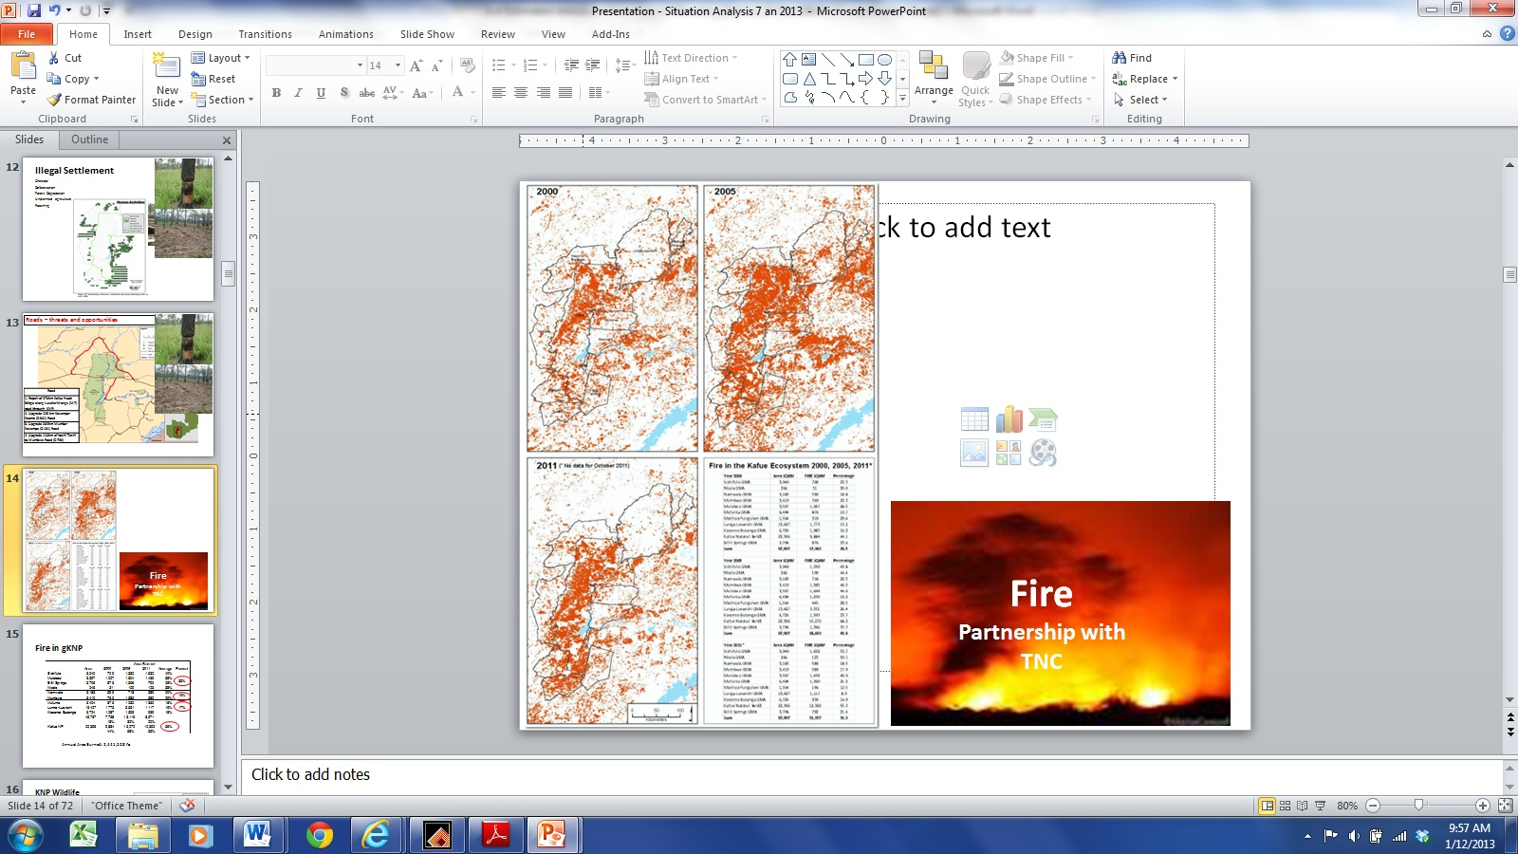

Table 3.2 Incidence of fire in greater Kafue NP (Source: TNC)
 |  | Area Burned (km²)
 | Area (km²) | 2000 | 2005 | 2011 | Average | Percent
Sichifulo | 3,040 | 709 | 1,330 | 1,632 | 40% | 35%
Mulobezi | 3,597 | 1,027 | 1,604 | 1,439 | 38% | 35%
Bilili Springs | 3,706 | 876 | 1,396 | 792 | 28% | 35%
Nkala | 246 | 51 | 109 | 123 | 38% | 35%
Namwala | 3,183 | 599 | 718 | 589 | 20% | 19%
Mumbwa | 3,410 | 760 | 1,585 | 580 | 29% | 19%
Mufunta | 6,404 | 876 | 1,230 | 1,360 | 18% | 17%
Lunga-Luswishi | 13,427 | 1,773 | 3,551 | 1,117 | 16% | 17%
Kasonso Busanga | 6,724 | 1,087 | 1,593 | 939 | 18% | 17%
 | 43,737 | 7,758 | 13,116 | 8,571
 |  | 18% | 30% | 20%
Kafue NP | 22,396 | 9,884 | 15,272 | 12,392 | 56%
 |  | 44% | 68% | 55%

Estimated impact of fire on carbon stocks in selected GMAs

Given that intense, late-season fires are prone to spread over a wider geographical area than early-season fires, it seems likely that late-season fires will account for a larger proportion of area affected by fire. However, in order to maintain conservativeness of assumptions, the potential impact of late-season fires on selected GMAs will be estimated based on an assumed ratio of geographical area affected of 1:1 for late and early-season fires, respectively. The estimated geographical area of woodlands affected by late-season fires in selected GMAs, and the impact on ecosystem carbon stocks, is presented in Table 3.3 below.

Table 3.3. Estimated area affected by fires and the consequent impact on ecosystem carbon stocks in selected GMAs
 | Lukwakwa | Chibwika-Ntambu | Namwala | Mufunta | Mumbwa
Area affected by fire (ha) | 48,666 | 27,975 | 63,533 | 111,667 | 97,500
Area affected by late-season fire (ha) | 24,333 | 13,988 | 31,767 | 55,833 | 48,750
Assumed period of fire regime for conversion to low-density woodland (years) | 50 | 50 | 50 | 50 | 50
Estimated loss of ecosystem carbon due to altered fire regime (t C/ha) | 21 | 21 | 18 | 18 | 18
Annual loss of ecosystem carbon (t C/year) | 10,118 | 5,816 | 11,608 | 20,402 | 17,813
Annual loss of ecosystem carbon (t CO₂/year) | 37,132 | 21,345 | 42,600 | 74,874 | 65,375

A relatively simple calculation is used to calculate annual losses of Carbon and CO₂, i.e.
Metric | Cryptosepalum forest | Miombo systems
Area burned in late season fires (ha): | 24,333 | 55,833
X loss/ha of Carbon (t C) | 21 | 18
÷ Assumed time it takes for total forest degradation (years) | 50 | 50
= loss of Carbon (t) | 10,219 | 20,099
Mass of CO₂ relative to C = 3.67
= loss of CO₂ (t / year) | 37,137 | 73,766
= CO₂ loss/ha late season burn (t / ha / year) | 1.52 | 1.32

The annual loss of carbon from late season fires varies from 1.32 t/ha in miombo to 1.52 t/ha in Cryptosepalum forest. This results in estimated CO₂ emissions of 182,000 and 58,000 tonnes CO₂/year in the proposed KNP and WLNP GMAs, respectively, valued at approximately $1,462,000 and $468,000. In KNP, on average 1,251,600 burn annually, and if we assume that half of this is late season fire the corresponding loss of CO₂ in Kafue NP is 839,209 tonnes worth $6.7m (@$8/t CO₂).

References
1 Guy, P. R. The influence of elephants and fire on a Brachystegia-Julbernadia woodlands in Zimbabwe. Journal of Tropical Ecology 5, 215-226 (1989).
2 Martin, R. B., Craig, G. C., Booth, V. R. & Conybeare, A. M. G. Elephant Mangement in Zimbabwe. A Review Compiled by Department of National Parks and Wild Life Management, Zimbabwe 124 (Department of National Parks and Wild Life Management, 1992).
- Ryan, C.M., Williams, M., Grace, J. (2010). Above- and belowground carbon stocks in a Miombo woodland landscape of Mozambique, Biotropica 43 (4): 423 - 432
- Ribeiro, N.S., Saatchi, S.N., Shugart, H.H., Washington-Allen, R.A. (2008). Aboveground biomass and leaf area index (LAI) mapping for Niassa Reserve, northern Mozambique. Journal of Geophysical Research – Biogeoscience 113
- Kamelarczyk, K.B.F. 2009. Carbon stock assessment and modelling in Zambia, a UN-REDD Programme study. MRV Working Paper. Series: UN-REDD Programme 4. FAO, UNDP and UNEP. 89 pp
- Ryan, C.M., Williams, M. (2011). How does fire intensity and frequency affect miombo woodland tree populations and biomass? Ecological Applications, 21(1): pp. 48–60

Refer to the reference attached on the Focal Area Results Framework when completing Table A.
TA includes capacity building, and research and development.
Assisted natural regeneration (ANR) is a simple, low-cost forest restoration method that can effectively convert deforested lands of degraded vegetation to more productive forests. ANR aims to accelerate, rather than replace, natural successional processes by removing or reducing barriers to natural forest regeneration such as soil degradation, competition with weedy species, and recurring disturbances (e.g., fire, grazing, and wood harvesting). It is proposed here because of the assumption that it can be applied to restoring Miombo areas where some level of natural succession of the ecosystem is already in progress compared to complete restoration. In Miombo woodlands it may include enrichment planting with desirable native species. The site-specific components of the ANR interventions will be decided during the PPG phase. Agro-forestry practices will be refined at PPG phase based on practices already developed and tested in Zambia, such as the planting of leguminous trees, e.g. Faidherbia Albida, in farmer fields, in association with both food and cash crops to enhance soil fertility and reduce the use of expensive inorganic fertilizers.
Such practices may mean planting a larger diversity of species or provenances, or trees bred for resistance to expected stressors. Modification of thinning schedules may help stabilize stands against drought, storms and disease and may also help capture added growth from CO2 fertilization.
Traditionally fire management involved suppression and management of intentional fires and lightning-ignited fires, fuel treatments, and other vegetation management treatments, often with the goal of altering the size and severity of subsequent wildfires across landscapes. Fire managers and scientists now widely acknowledge the critical and natural role fire plays in most terrestrial ecosystems and Miombo ecosystems in particular – See Annex A. However the last several decades have seen a paradigm shift from a suppression orientation to an acknowledgement of the need to use wild-land fire as a whole-landscape management tool, particularly in light of climate chance. Effective climate-resilient fire management at the landscape scale will thus build on traditional practices but is different in that it requires new monitoring and assessment tools, as well as management practices, to take advantage of past fires, prescribed fire treatments, and local topography and climate change-induced impacts to understand and manage forests at the landscape scale in the context of changing climate conditions.
This data set will be hosted in the National Remote Sensing Centre in Lusaka
In Zambia there are vast amounts of biodegradable wastes such as charcoal fines, wood waste, agricultural by-products and municipal wastes which would otherwise be wasted and which can be turned into briquettes, thus reducing pressure on forests from wood fuel collection. These waste products come from charcoal kilns, factories, agricultural processors, and carpentry shops, saw mills and charcoal vendors. Briquetting requires a binder to be mixed with the charcoal fines or sawdust, a press to form the mixture into a cake or briquette which is then passed through a drying oven to cure or set it by drying out the water so that the briquette is strong enough to be used in the same burning apparatus as normal lump charcoal. Starch (often cassava) is used as a binding agent. The exact type of briquetting machines to be piloted will be analyzed and determined at the PPG stage.
To be calculated as percent of subtotal.
On an exceptional basis, PPG amount may differ upon detailed discussion and justification with the GEFSEC.
PPG fee percentage follows the percentage of the GEF Project Grant amount requested.
Part II should not be longer than 5 pages.
Zambia is among the 6 biggest global emitters of greenhouse gases from deforestation (Boucher, 2008) and according to the OSIRIS global Reduce Emissions from Deforestation and Forest Degradation (REDD+) and Carbon Stock Enhancement economic model can contribute 4.3 % of the global REDD+ abatement potential (Bush et al. 2009).
Mwitwa, J. and Makano, A. Charcoal demand, production and supply in the Eastern and Lusaka Provinces. Mission Press, Ndola. Zambia (done for USAID), 2012
Opportunities and challenges for sustainable management of miombo woodlands: the Zambian perspective, Fabian M. Malambo and Stephen Syampungani (Copperbelt University, School of Natural Resources), Working Papers of the Finnish Forest Research Institute 98
Draft Report, Stakeholder Analysis and Engagement Plan for Central Province, Rosemary Fumpa-Makano, PhD. Prepared for UN-REDD, December 2011
First National Communication, UNFCCC, 2005
Ministry of Tourism, Environment and Natural Resources & UNDP, The Economics of Climate Change in Zambia, February 2011
Ibid
Mwitwa, J. and Makano, A. Charcoal demand, production and supply in the Eastern and Lusaka Provinces.
ANNEX 8 of the UNDP/GEF (Draft) Prodoc “Strengthening Management Effectiveness and Generating Multiple Environmental Benefits within and around Protected Areas in Zambia”. Fires in Miombo Ecology and Effects on Emissions in GKNP, C4 EcoSolutions, 2013.
Ribeiro et al (2008) estimated that aboveground biomass density of low and high-density Miombo woodlands varied by a factor of 3.33 (ranging from 10.5 to 35 tonnes C/ha). It is assumed that a long-term fire regime of late season fires at excessive return intervals will drive the conversion of high-density woodland to low-density woodland. If an above ground biomass density of 26.1 and 29.7 t C/ha is assumed for Miombo and Cryptosepalum, respectively, a fire regime of excessive late-season burning is expected to result in a loss of ecosystem C of 18.3 and 20.8 t C/ha, respectively (67.1 and 76.3 t CO2/ha). Based on long-term fire studies on Miombo woodland in Zimbabwe, high-density woodland is degraded to low-density woodland within 102 to 50 years.
Strengthening Management Effectiveness and Generating Multiple Environmental Benefits within and around Protected Areas in Zambia
See Annex A
Sustainable Forest Management Initiatives of relevance to REDD + in Zambia, 1st Draft Report – 23rd June 2013, Gun Mickels-Kokwe and Misael Kokwe, prepared for UN-REDD
Ibid, pg. 30
See footnote #15
Ibid
These include both nationally relevant activities and activities specific to the province
MLNREP – Proposal for Special Funding to Improve Service Delivery and Exploitation of the Potential in the Lands, Forestry and Environment Sectors to Enhance Revenue Collection and Create Jobs (internal document) – July 2012
Ibid, pg. 13
Currently Joint Forest Management Plans have been developed for seven pilot forest areas across the country. The implementation of the JFM plans stalled in the mid-2000s.
UN-REDD was supposed to officially end in August 2013 but there is a strong likelihood of a no- cost extension for 16 months up to December 2014
Excludes UNDP Zambia CO co-financing – see Section B.3
For example, improved fallows are established by planting leguminous trees, such as Sesbania sesban, Tephrosia vogellii, Crotalaria spp. and Cajanus cajan to speed-up soil fertility restoration. In some cases mixed intercropping with coppicing species, such as Gliricidia sepium, Calliandra calothyrsus and Leuceana trichandra, are used to obviate the replanting of non-coppicing species
FOREST MANAGEMENT PRACTICES WITH POTENTIAL FOR REDD+ IN ZAMBIA, FINAL REPORT, Misael Kokwe with contributions from G. Mickels-Kokwe, UN REDD (March 2012)
During the PPG phase the specific legal arrangements of the VAGS will be formalized based on provisions of the National Decentralization Policy and Draft Forestry Act. If the VAG structure is not relevant we will explore the Area Development Committee (ADC) structure in the targeted chiefdoms with conservancies created as a legal basis for the proposed activities.
While it is envisioned that most of the VAGs will on customary land but the zones could also include Local Forests, which are protected forest areas with the management objective of meeting the need for forest products for present and future generations of local people and settlements. The institutional arrangement for the management of the Local Forests is the same as the one for the National Forests, where government (via the Forestry Department) is the manager.
Fire and remote sensing trip report, Kafue National Park, USFS and TNC, October 2011
Letter to MLNREP Minister from CIFOR and Copperbelt University, August 2012
The Dynamics of Charcoal and Indigenous Timber Trade in Zambia, Davison J. Gumbo, Kaala B. Moombe, MercyM. Kandulu and Gillian Kabwe
Taken from Decentralised NRM Programme (DNRMP) - A Decentralised Innovative Programme on Integrated Forest and other Natural Resources Management in Zambia, Programme Identification Mission Report, Draft Identification Report 15 Aug 2012 Göran Nilsson Axberg, Abraham Makano, Patrick Matakala, Guni Mickels Kokwe
FOREST MANAGEMENT PRACTICES WITH POTENTIAL FOR REDD+ IN ZAMBIA, FINAL REPORT, March 2012, Prepared for the Zambian Forestry Department (MLNREP) and UN-REDD
Application of Assisted Natural Regeneration to Restore Degraded Tropical Forestlands, Kenichi Shono, Ernesto A. Cadaweng, and Patrick B. Durst, Restoration Ecology Vol. 15, No. 4, pp. 620–626 December 2007
MINISTRY OF TOURISM, ENVIRONMENT AND NATURAL RESOURCES, FORMULATION OF THE NATIONAL ADAPTATION PROGRAMME OF ACTION ON CLIMATE CHANGE (NAPA) (Final Report) . September 2007
C4 EcoSolutions (Cape Town) Prepared as part of the Report on the potential for sustainable forest management and REDD+ in Game Management Areas in Zambia for the PPG phase of the GEF project: Strengthening management effectiveness and generating multiple environmental benefits within and around protected areas in Zambia
Annex 2: Contribution on Improved Kilns to Reducing Deforestation A number of recent studies have demonstrated that for areas where charcoal is a primary driver of deforestation the introduction of improved kilns can be a powerful tool in both reducing emissions and increasing forest cover. The results of a study by the World Bank (Environmental Crisis or Sustainable Development Opportunity? Transforming the charcoal sector in Tanzania - A Policy Note, World Bank, 2009) on the impacts of improved kilns in a Miombo woodlands context demonstrated that improved kilns were by far the most effective instruments in improving forest cover compared to a business-as-usual scenario (see diagram below which illustrates the combined and individual impacts of the three policy options on forest cover). Table 2.1 - IMPACT OF IMPROVED KIN TECHNOLOGY ON FORESTS (Source: World Bank) 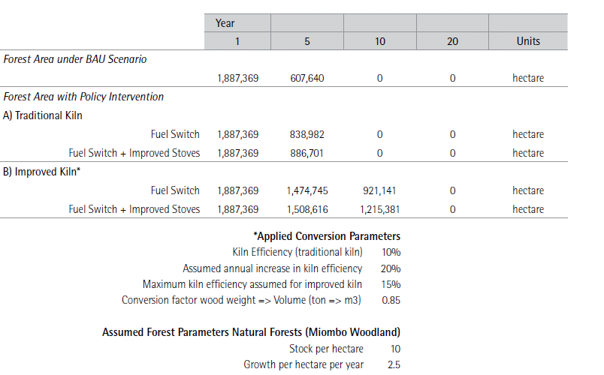 The diagram above illustrates that improved kiln technology – although only increasing efficiency – has a significant positive impact on forest area. The relatively larger impact of improved kiln technology on forest management, compared to policy interventions on the consumption side, can be explained by the fact that production-side measures are not offset by population growth and, thus, have a more profound impact. Annex 3 – Excerpted Section on Briquetting Systems from CleanStart Business Plan – Uganda Case Study of Briquetting Potential Briquetting Market The briquette making market in Uganda is currently quite heavily donor driven and is at market development stage, mainly through NGOs such as Living Earth, GIZ and CREEC, although some new companies have been set up such as Kampala Jellitone Suppliers (KJS), and Green Bio Energy Ltd. Their focus is on supporting local communities in Uganda to develop a whole range of products including briquettes, with Living Earth having supported three entrepreneurs to produce briquette machines to be able to produce briquettes, as well as training 2 stove producers to produce cook stoves that uses briquettes. It has worked with 17 briquette makers in Uganda, providing them with necessary technology training and a business model. The number of briquette producers and daily production can easily be raised from 17 briquette producers to 50 producers and from 8 tonnes to 50 tonnes per day. Currently, the size of the market is not known, as the total amount of materials suitable for briquetting production has not been adequately estimated, although it is believed to be substantial. Using the baseline of the usage of charcoal among Ugandan households (22% of households in 2009/10), it can be estimated that several hundred thousand Uganda households could start using briquettes as an alternative to charcoal with the right development of the sector. Briquette making machinery generally costs upwards of US$ 376, and can produce up to 1 tonne of briquettes per day at full capacity. Most briquette producers manage to produce about 800-1,000 kg of briquettes per day with high quality machines. SWOT Analysis for Briquetting Production in Uganda The main Strengths and Opportunities for CleanStart for briquetting production are as follows: - There are vast amounts of biodegradable wastes such as charcoal fines, wood waste, coffee husks, bagasse, banana peels and municipal wastes which can be turned into briquettes. These come from sugar factories, coffee processors, and carpentry shops and saw mills, charcoal vendors, and municipals. - Currently few financial institutions are interested in funding SMEs in briquette machine fabrication and briquette making and this presents an opportunity for CleanStart partners to provide asset loans for fabrication and working capital loans for buying raw materials. - A number of organisations, including Living Earth, have the necessary technologies to train briquette makers within the market and since briquettes have an advantage over other fuels, there is potential for growth of the sector. - The UNDP GEF Charcoal project will be able to provide capacity building of briquette producers and awareness raising which will provide CleanStart with a great leveraging opportunity. The main Weaknesses and Threats for CleanStart in Briquette financing are: - There is limited awareness of briquettes as an alternative source of fuel among intended users and acceptance of briquettes as an alternative to charcoal and other fuels may take time and dampen the financing market. - There is currently competition from traditional cooking fuels such as firewood and charcoal and ingrained social habits which may make the market for briquettes slow to pick up and demotivate SMEs from briquette production. - The current relatively uncoordinated and fragmented nature of the briquette production market may make it difficult for financial institutions to fund the sector. It would be easier to fund briquette producers that belong to organized groups. - Weak linkages in the briquette value chain may make it difficult for an increase of competitiveness and growth which will prove a disincentive to financing of the value chain. - Although a renewable energy policy exists there is also a lack of clarity on standards and regulations through UNBS, as well as official taxes that entrepreneurs need to pay which may make briquetting an unattractive sector for some players. Annex 4 – Excerpt of Chapter on Agro-Forestry from UN-REDD Report Agro-forestry in Zambia was introduced by the Adaptive Research Planning Teams (ARPT), now referred to as Farming Systems Research Teams (FSRT) of the MAL Research Branch. In the 1980s, the objective was to conduct participatory on-farm research, addressing the specific socio-economic and biophysical constraints in all nine provinces, providing technologies that would meet the livelihood needs of the majority, the resource-constrained smallholders in risky environments. Since then, the agro- forestry technology has further been developed through the combined efforts of MAL, the World Afro-forestry Centre (ICRAF) and, more recently, the Golden Valley Research Trust (GART) and Conservation Farming Unit (CFU). In the COMESA region, SADC and East Africa, a number of studies have highlighted the potential of agro-forestry for carbon sequestration. The potential for agro-forestry is considered high, even in densely populated areas. In Malawi, for example, where land holding per household ranges from 0.5 to 3 ha, the total land under agro forestry is estimated to be 45% to 85% of arable land. Wood production under agro-forestry may reach about 2.1 tonnes (equivalent to 1.0 tC) per ha per year (Bunderson et al. 1997). Average farm sizes in western Kenya range from 0.6 ha to 1.4 ha but are able to store 6.5 to 12.4 t of C per farm with trees representing the most important aboveground carbon pool (Henry et al. 2009). Currently, there are no estimates for Zambia. A number of agroforestry technologies have been tested in Zambia. Improved fallows are established by planting leguminous trees (e.g. Sesbania sesban, Tephrosia vogellii, Crotalaria spp. and Cajanus cajan) to speed-up soil fertility restoration. Mixed intercropping with coppicing species (e.g. Gliricidia sepium, Calliandra calothyrsus and Leuceana trichandra) are used to obviate the replanting of non-coppicing species. Fruit trees are grown around the homesteads for nutrition and income generation. Currently the technology that has gained momentum is the promotion of Faidherbia albida (winter thorn, known as musangu locally). Winter thorn is inter-planted with both food and cash crops to enhance soil fertility and to reduce the need for costly inorganic fertilizers. Inorganic fertilizers contribute to GHG emissions both in production line and, if applied in-correctly, also on farm. Faidherbia albida is a central component in the Conservation Agriculture programme being implemented throughout most of the country by MAL in collaboration with CFU, FAO and other partners. Conservation Agriculture with Trees is currently working with 179,000 farmers across agro-ecological regions II and I: in Southern, Lusaka, Central, Western and Eastern Provinces. An innovative and exploratory agro-forestry programme is the Mitengo Partners’ Trees on Farms initiative promoting the growing of trees in association with crops. The Mitengo Partners are Dunavant Ltd. an industry lead company in cotton production and ginning; MUSIKA, a Zambian agribusiness NGO; and Shared Value Africa, a carbon advisory and research agency, who work in 77 close collaboration with MAL and a consortium of collaborating organizations7. The Trees on Farms Programme started with only about 2,400 cotton-growers in Eastern Province in 2011. By 2013, Trees on Farms attracted 20,000 farmers across Eastern, Western and Southern Provinces of Zambia, showing its potential for expansion and replication. 5.9.1. Agro-Forestry: Compliance with SFM and Good Practice Criteria Agro-forestry complies well with SFM and Good practice criteria. Agro forestry systems provide a wide range of products, for different cropping systems and farm types, that are good for household food security and income generation. The practice provides for self- and on-farm- employment to communities in rural areas. Soil fertility maintenance and improvement, and soil and water conservation are the key premises of agro forestry technologies. Agro-forestry is a predominantly people based technology for the benefit of the communities and the environment. The development of the technologies has benefitted appreciably from indigenous technical knowledge in areas such as naturally occurring- nitrogen fixing plants and good fodder plants. Women participation is as in any other conventional farming practices in Zambia and the various technologies tested before and the ones being vigorously promoted at the moment have no foreseen cultural barriers. In terms of policy, agro-forestry performs well as the practice is well institutionalized and established in a wide range of research and extension systems, governmental, NGO and research-based. The agro-forestry sector is also supported by clearly formulated agricultural policies. However, there is need for enhanced inter-sector collaboration between key REDD+ institutions, e.g. Agriculture, Forestry and Lands. 5.9.2. Agro-Forestry: Documentation & Lessons Learnt Agro-forestry is a very well-documented practice. Findings from the World Agroforestry Centre research in Eastern Province are published in peer-reviewed international journals. The Conservation Agriculture programme, FAO and MAL have prepared numerous practical publications and manuals. GART publishes research findings annually. Information on the soil carbon binding capacity of different agro-forestry practices is available on the internet. References and good practices in agro-forestry for Zambia are found in Kokwe (2004). The innovative Mitengo Carbon Partner project is featured below in detail in Box 10. 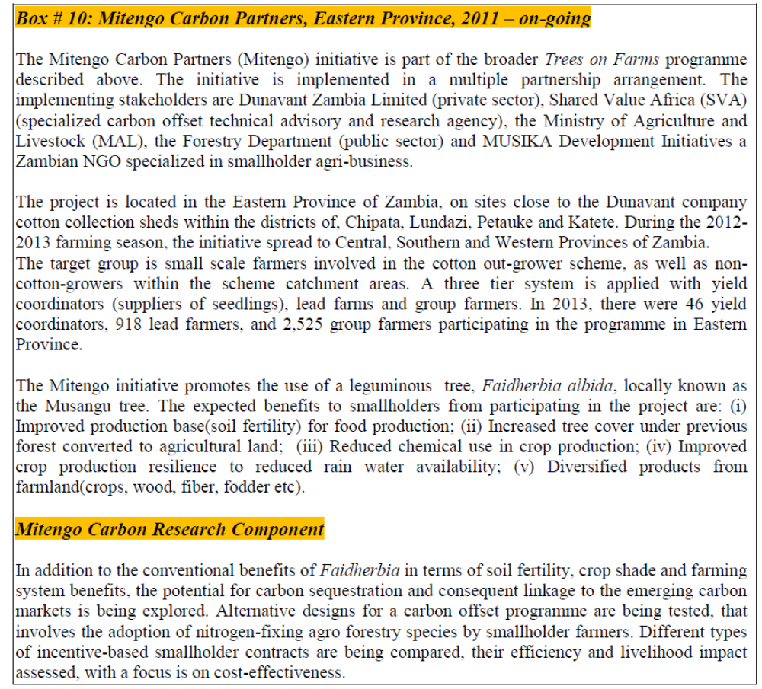 5.9.3. Policy considerations and Potential for REDD+ (SWOT) Carbon-related agro-forestry initiatives will need substantial policy and institutional support to succeed, as indicated in Figure 19 below. In particular, it will be important to strengthen dialogue and cross-sector collaboration between agriculture, lands and forestry. Figure 19. Agro-forestry: SWOT analysis of policy and potential for REDD+ 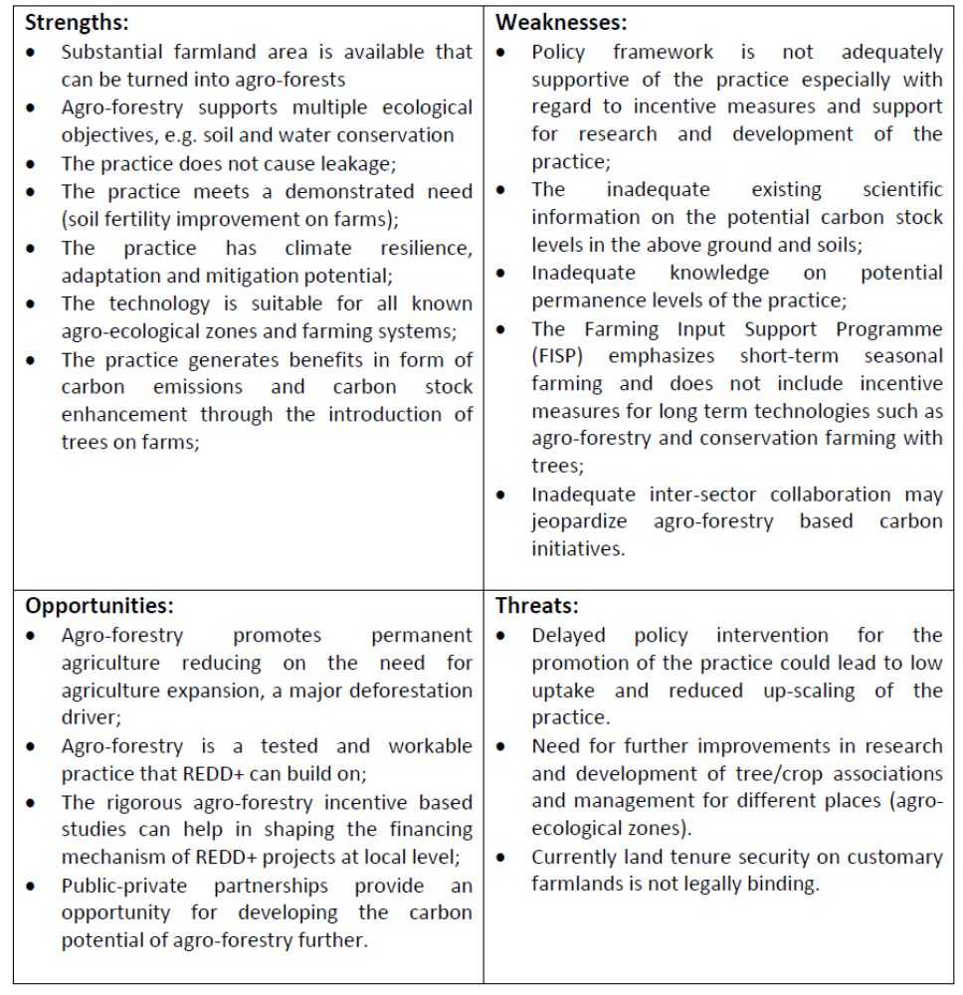 Annex 5 – Case Study of JFM management practices in Chibwe National Forest, Kapiri Mposhi 